**DEWATERING PROJECT**

**DESIGN REPORT**

**13 March 2024**

Contents

[1. PREFACE 5](#_Toc161516395)

[2. DESIGN 5](#_Toc161516396)

[2.1. Scope of design 5](#_Toc161516397)

[2.2. Dewatering system 5](#_Toc161516398)

[2.3. Dewatering calculations 6](#_Toc161516399)

[2.3.1. Design methodology 6](#_Toc161516400)

[2.3.2. Permeability coefficient 7](#_Toc161516401)

[2.3.3. Discharge Quantities & Pumping 7](#_Toc161516402)

[2.3.4. Water drawdown inside the project area 8](#_Toc161516403)

[2.3.5. Water drawdown on adjacent structures 9](#_Toc161516404)

[2.3.6. Discharge and Pumping lines sizing 13](#_Toc161516405)

[2.3.7. Pumps 13](#_Toc161516406)

[2.3.8. Filter pack 13](#_Toc161516407)

[2.3.9. Well screen 13](#_Toc161516408)

[2.3.10. Main Discharge Lines 15](#_Toc161516409)

[**2.4.** **Stresses and Settlements using cohesive soil material** 15](#_Toc161516410)

[**2.5.** **Settlements using cohesionless soil conditions:** 21](#_Toc161516411)

[2.6. Displacement at two Nodes areas, using analytical cohesion soil model calculations and numerical model as well. 27](#_Toc161516412)

[2.6.1. Excavation and dewatering numerical modeling 28](#_Toc161516413)

[2.7. Maximum Displacement and Differential Displacements at buildings Nodes 37](#_Toc161516414)

[2.7.1. Problematic Differential Settlements at buildings Nodes 39](#_Toc161516415)

[2.7.2. Proposal for Improving Settlements 40](#_Toc161516416)

[2.8. Recommendation 41](#_Toc161516417)

[2.8.1. Supporting system 41](#_Toc161516418)

[2.8.2. Contractor’s precautious measures During Excavations 42](#_Toc161516419)

[3. WORKS EXECUTION 43](#_Toc161516420)

[3.1. Execution steps 43](#_Toc161516421)

[3.2. Sequence of work 43](#_Toc161516422)

[3.3. Control Panels 43](#_Toc161516423)

[3.4. Connection from pumps to discharge Lines 43](#_Toc161516424)

[4. COMMISSIONING 43](#_Toc161516425)

[5. HEALTH AND SAFETY 44](#_Toc161516426)

[ANNEXES 45](#_Toc161516427)

[ANNEX A1 46](#_Toc161516428)

[Pumps 46](#_Toc161516429)

[ANNEX A2 46](#_Toc161516430)

[Method1-Big Well Equivalent 46](#_Toc161516431)

[ANNEX A3 46](#_Toc161516432)

[Superposition Method 46](#_Toc161516433)

[Wells-InsideProject 46](#_Toc161516434)

[ANNEX A4a 46](#_Toc161516435)

[Superposition Method 46](#_Toc161516436)

[Wells-A1,A2,A3,A4,A5 46](#_Toc161516437)

[Cohesion soil material 46](#_Toc161516438)

[ANNEX A4b 46](#_Toc161516439)

[Building A 46](#_Toc161516440)

[Schemertmann method 46](#_Toc161516441)

[Cohesionless soil material 46](#_Toc161516442)

[ANNEX A4c 46](#_Toc161516443)

[Building A 46](#_Toc161516444)

[Schemertmann method 46](#_Toc161516445)

[Summarizes Settlements 46](#_Toc161516446)

[ANNEX A5a 46](#_Toc161516447)

[Superposition Method 46](#_Toc161516448)

[Wells- C1,C2,C3,C4,C5 46](#_Toc161516449)

[Cohesion soil material 46](#_Toc161516450)

[ANNEX A5b 46](#_Toc161516451)

[Building C 46](#_Toc161516452)

[Schemertmann method 46](#_Toc161516453)

[Cohesionless soil material 46](#_Toc161516454)

[ANNEX A5c 46](#_Toc161516455)

[Building C 46](#_Toc161516456)

[Schemertmann method 46](#_Toc161516457)

[Summarizes Settlements 46](#_Toc161516458)

[ANNEX A6a 46](#_Toc161516459)

[Superposition Method 46](#_Toc161516460)

[Wells- B,B1,B2,B3,B4 46](#_Toc161516461)

[Cohesion soil material 46](#_Toc161516462)

[ANNEX A6b 47](#_Toc161516463)

[Building B 47](#_Toc161516464)

[Schemertmann method 47](#_Toc161516465)

[Cohesionless soil material 47](#_Toc161516466)

[ANNEX A6c 47](#_Toc161516467)

[Building B 47](#_Toc161516468)

[Schemertmann method 47](#_Toc161516469)

[Summarizes Settlements 47](#_Toc161516470)

[ANNEX 7a 47](#_Toc161516471)

[Superposition Method 47](#_Toc161516472)

[Wells- D1,D2,D3 47](#_Toc161516473)

[Cohesion soil material 47](#_Toc161516474)

[ANNEX A7b 47](#_Toc161516475)

[Building D 47](#_Toc161516476)

[Schemertmann method 47](#_Toc161516477)

[Cohesionless soil material 47](#_Toc161516478)

[A7c Build D-SettlementSum 47](#_Toc161516479)

[ANNEX A7c 47](#_Toc161516480)

[Building D 47](#_Toc161516481)

[Schemertmann method 47](#_Toc161516482)

[Summarizes Settlements 47](#_Toc161516483)

[A8 Loads of Neighbor Buildings 47](#_Toc161516484)

[ANNEX 8a 47](#_Toc161516485)

[Superposition Method 47](#_Toc161516486)

[Point B 47](#_Toc161516487)

[Cohesion soil material 47](#_Toc161516488)

[ANNEX 8b 47](#_Toc161516489)

[Superposition Method 47](#_Toc161516490)

[Point F 47](#_Toc161516491)

[Cohesion soil material 47](#_Toc161516492)

[Foundation depth 2.50m 47](#_Toc161516493)

[A8c\_SuperWells-F5m 47](#_Toc161516494)

[ANNEX 8c 47](#_Toc161516495)

[Superposition Method 47](#_Toc161516496)

[Point F 47](#_Toc161516497)

[Cohesion soil material 47](#_Toc161516498)

[Foundation depth 5.00m 47](#_Toc161516499)

[-ANNEX A9 48](#_Toc161516500)

[Dewater Lines Sizing 48](#_Toc161516501)

[ANNEX A10 48](#_Toc161516502)

[FilterPack calculations 48](#_Toc161516503)

[ANNEX A11 48](#_Toc161516504)

[WellScreen calculations 48](#_Toc161516505)

[ANNEX A12 48](#_Toc161516506)

[Permeability index 48](#_Toc161516507)

[ANNEX A13 48](#_Toc161516508)

[PLAXIS NUMERICAL ANAL 48](#_Toc161516509)

# PREFACE

This design refers to the dewatering system for a Project.

The project is located at City Center.

# DESIGN

## Scope of design

The scope of this design is the dewatering system applied during construction of the project, to allow excavation to reach and maintain final dry level.

It is mentioned that shoring system design is not in CONSULTANT’s scope. The dewatering system is only in the scope and within this, CONSULTANT is proposing also relevant shoring system to diminish the settlements and protect the heritage buildings in the vicinity of the project.

Detail design of the shoring system must be implemented by others.

The dewatering Contractor has to verify the present design, based on the actual site conditions, the tested pumping rates, the final shoring methodology and the used materials characteristics and adjust the sequence of the operation of the pumps, their depth, etc.

Moreover, and based on the geotechnical report, there are not compressible alluvial clay or peat soils in the project area.

## Dewatering system

As per para. 10.1 of the Geotechnical report, soil improvement is required at the building location, consisting of 7.0m excavation and replacement of the ground material.

The Dewatering system as designed by CONSULTANT is composed of 6 duty (and 3 standby) submersible pumps of 4”, placed in sump pits with filter pack at 8.6m depth, as shown in the attached design drawings and calculations.

The pumps will be placed in the pits and will be lowered gradually, following the excavation rate.

A slotted casing shall be installed and surrounded with filter aggregate, as shown in the attached updated drawing S.2.

The basic setout of the wells is shown below (*Construction dewatering and groundwater control, New Methods and Applications, J. PATRICK POWERS, P.E., ARTHUR B. CORWIN, et al, 2007*)

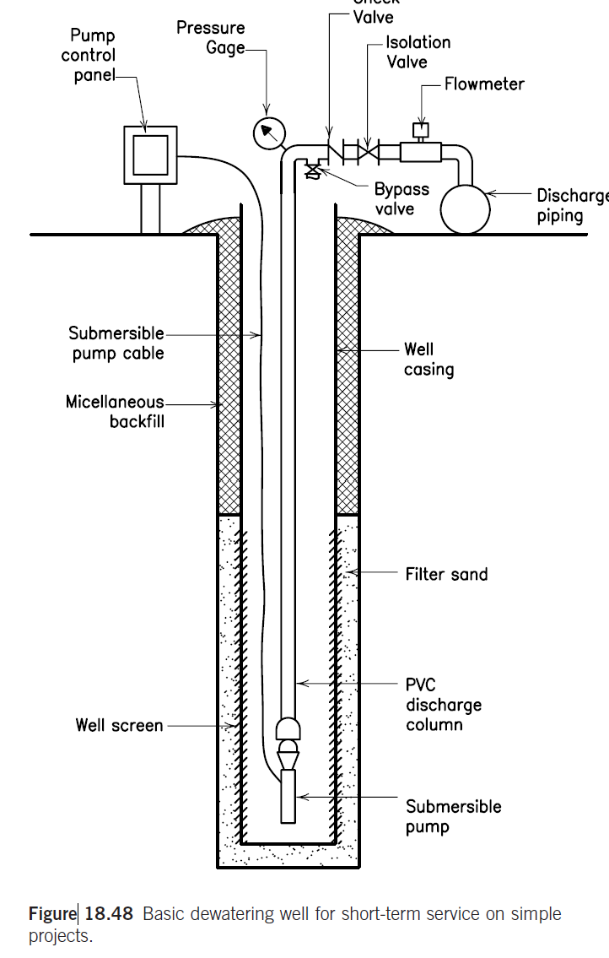

A riser pipe HDPE 110mm external diameter will be installed on the pump to direct the water to the ground floor and with horizontal pipes HDPE 200mm external diameter to the sedimentation tank and then, to the discharging lines of 500mm.

The pipes material of the riser and horizontal pipes will be HDPE or equivalent approved.

Temporary trenches 50x50cm filled with aggregates will be constructed, to facilitate the direction of the water flow to the pump pits. The trenches will be constructed at various levels during the excavation.

The pumping will continue until the uplift force due to floating will be balanced from the building weight and any foundation tension piles, with a safety factor of 50%.

The main Contractor and his specialized sub-contractor have to submit detail proposal of the various stages, trenches, filters, permeability index based on pumping test and dewatering flow, pumps, etc. and the uplift balance calculations for approval from the supervision Consultant. Also has to prepare detail shop drawings of the external discharge lines, taking into account of all existing in the area networks, in coordination with the supervision consultant and the authorities.

## Dewatering calculations

### Design methodology

#### General

In CONSULTANT’s scope the dewatering system is included. The supporting system is out of scope.

Calculations of the pumping rate, the drawdown and pumps are provided with the attached Excel workbook (240313-AlBunt\_calcs.xlsm), based on

1. *A Practical Guide to Dewatering, 2nd Edition, Pat M. Cashman and Martin Preene*
2. *Construction dewatering and groundwater control, New Methods and Applications, J. PATRICK POWERS, P.E., ARTHUR B. CORWIN, et al,*
3. *As per standard practice with other Municipality’s similar projects*.

Excel calculation provided in the sheet (Annex A10 FilterPack), considering the available data from the three boreholes and available depths of the Geotechnical investigation that received from the Client (Ref S22000091 Rev.5/11-3-2023).

In addition to these, settlement numerical analysis also conducted using the Plaxis software, to estimate the settlements under the adjacent buildings. For this, the shoring system deformations disregarded by implementing movement restrictions of the supporting wall panels, anchors de-activated, in line with the reviewer’s directions.

### Permeability coefficient

The permeability coefficient K as is proposed by the geotechnical report falling head test, of the geotechnical report (Ref S22000091 Rev.5/11-3-2023 para.7.3), is:

|  |  |  |
| --- | --- | --- |
| PERMEABILITY INDEX as per para. 7.3 of the Geotechnical report | | |
| Test Depth (m) | Permeability (m/sec) | Drainage characteristics |
| 3 | 1.70E-06 | Low Permeability |
| 5 | 2.00E-06 | Low Permeability |
| 7 | 1.90E-06 | Low Permeability |
| TAKEN | 1.90E-06 | At 7.0m depth (excavation) |

### Discharge Quantities & Pumping

The discharge pumping quantity is calculated with the attached Excel sheet Annex (sheet “A2 Meth1-BigWellEquival”), based on a big equivalent well, bibliography:

1. *A Practical Guide to Dewatering, 2nd Edition, Pat M. Cashman and Martin Preene*
2. *Construction dewatering and groundwater control, New Methods and Applications, J. PATRICK POWERS et al*
3. *Deep excavation Theory and Practice Chang-Yu Ou*

The required pumping discharge quantities are calculated based on the big equivalent model (Construction dewatering and groundwater control, New Methods and Applications, J. PATRICK POWERS, P.E., ARTHUR B. CORWIN, et al).

The following formulas are applied:

$$Q=\frac{πk(H^{2}-h^{2})}{ln\frac{R_{0}}{r_{w}}}$$

$$R_{0}= r_{1}+ r_{w}$$

$$r_{w}= \sqrt{\frac{ab}{π}}$$

$$r_{1}= 3000(H-h_{w})/\sqrt{K}$$

The required water pumping discharge quantity is calculated to 30 m3/h

Six (6) duty pumps of 4” diameter are selected. Their working rate of each pump is selected to be **14m3/h**, to keep the drawdown inside the project within the required depth from surface of 7.6m (required flow drawdown 6.70m), see Excel sheet and Annex 3 (sheet “A3 SuperWells-InsideProject”).

During the dewatering phase and the long term pumping, the total flow Qtot of all pumps will be stabilized to the theoretically required discharge flow and the pumps have to be adjusted to the actual working capacity as per the dewatering site conditions.

### Water drawdown inside the project area

The drawdown is calculated in the attached Excel sheet, based on the Wells superposition model, Annex 3 (sheet “A3 SuperWells-InsideProject”).

#### Wells superposition model

The superposition model of all wells is applied at the center C and the points D and E inside the project, as shown in the below sketch (dwg S13)

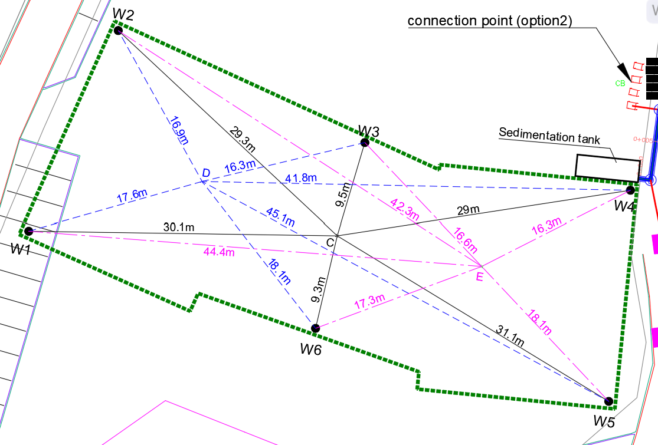

(Deep excavation Theory and Practice Chang-Yu Ou, para 9.4.2.1, Eq. 9.18):

$$h_{i}=\sqrt{H^{2}- \frac{Q_{i}}{πk}ln\left(\frac{R}{r_{i}}\right){}}$$

Where

hi = hydraulic head at distance ri from well #i

H= Hydraulic head of the original water table

Qi = Pumping water quantity at well #i

k = permeability index (m/sec)

R = Total Radius of influence of Well = R1+rw

Where

rw = well #i radius, and



Applying this formula, the drawdowns inside the project area are as follows (Excel sheet and Annex 3):

* Point C: 8.09m
* Point D: 7.12m
* Point E: 7.25m

These are more than the required drawdown of 6.70m

### Water drawdown on adjacent structures

#### The water drawdown at the heritage buildings is calculated applying two different models, the Big equivalent model, Annex 2, (sheet “A2 Meth1-BigWellEquival”) and the Wells superposition model Annex 3, (“A3 SuperWells-InsideProject”) as well.

The distance of the wells from the nearest heritage and other buildings is shown in the drawings:

* For Building A and points A1,A2,A3,A4,A5 in dwngs S12a,b,c,d,e
* For Building C and points C1,C2,C3,C4 in dwngs S13a,b,c,d
* For Building B and points B,B1,B2,B3,B4 in dwngs S14a,b,c,d,e
* For Building D and points D1,D2,D3 in dwngs S15a,b,c

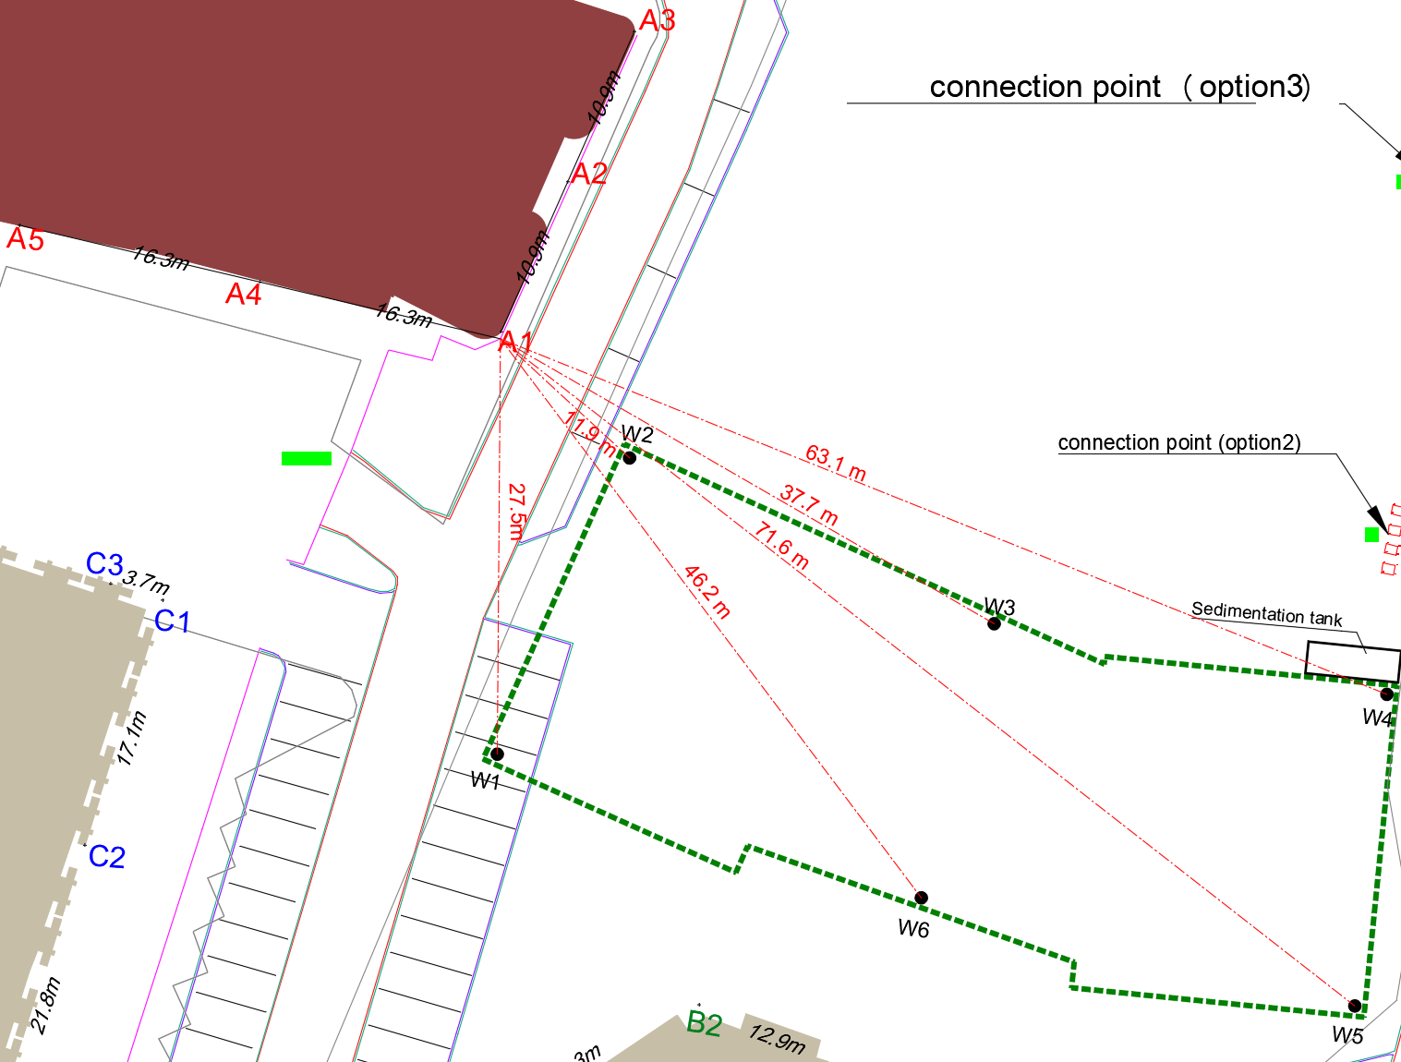

#### Big well equivalent model

The big well model could be considered as a very rough estimate however more accurate estimate is provided in item.(2.3.5.2)

Depuit-Thiem's equation: (Free aquifer - Drawdown is far smaller than aquifer thickness)

From this, the drawdown at distance r from the center is given as:

$$h=\sqrt{H^{2}- \frac{Q}{πk}\ln{(\frac{r}{r_{w}})}}$$

From the attached spreadsheet and Annex 2, the drawdown is 0.76m

Alternatively, is calculated from the formula.

$$H_{x}= \frac{R_{x1}}{3000\sqrt{K}}+h_{w}$$

This gives a drawdown beneath the heritage building of 0.76m (Annex 2).

#### Wells superposition model

The wells superposition method is applied to find the cumulative drawdown at a point

##### Wells radius of influence

The radius of influence of each separate well, is calculated from the equation of above para. 2.3.4.1 and is

$$R=R_{1}+r_{w}$$

Where

R = Total Radius of influence of Well

rw = well #i radius, and



As per the calculations in the attached Excel sheet “A3 SuperWells-InsideProject” is:

$R=R_{1}+r_{w}$ = 27.71 + 0.31 = 28.01 m

The influence radius of the wells and their surrounding curve is shown in below figure and the attached dwg S12a.

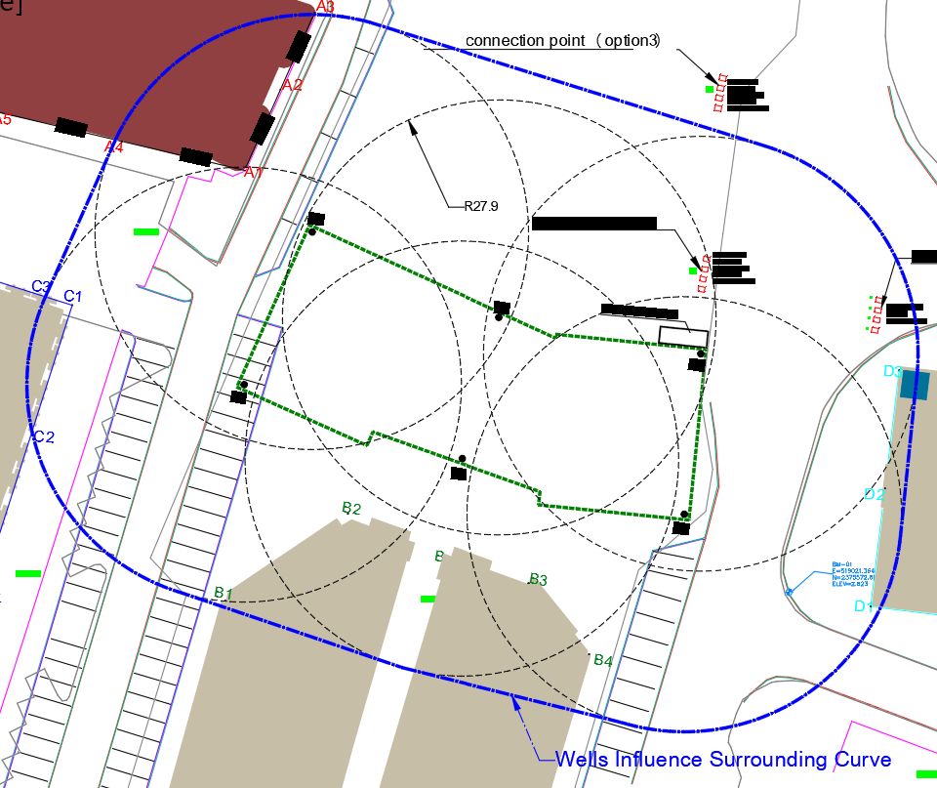

Points outside the wells influence surrounding curve, will not be affected from the dewatering, since the drawdown will be 0.

So, drawdown and settlements of points inside the surrounding curve are examined.

#### Wells superposition drawdown

The superposition model of all wells is applied based on the below references:

1. NAFAC P-418, page 4-19:



1. Deep excavation Theory and Practice Chang-Yu Ou, para 9.4.2.1, Eq. 9.18):

$$h_{i}=\sqrt{H^{2}- \frac{Q_{i}}{πk}ln\left(\frac{R}{r_{i}}\right){}}$$

Where

hi = hydraulic head at distance ri from well #i

H= Hydraulic head of the original water table

Qi = Pumping water quantity at well #i

k = permeability index (m/sec)

R = Total Radius of influence of Well = r1+rw

Where

rw = well #i radius, and



The water drawdown due to pumping is calculated with the separate wells’ superposition methodology in the attached spreadsheets, as follows:

1. For building A, sheet “*4a SuperWells-A1,A2,A3,A4,A5*”
2. For building C, sheet “*A5a SuperWells-C1,C2,C3,C4,C5*”
3. For building B, sheet “*A6a\_SuperWell-B,B1,B2,B3,B42.5m*”
4. For building D, sheet “*A7a SuperWells-D1,D2,D3*”

jj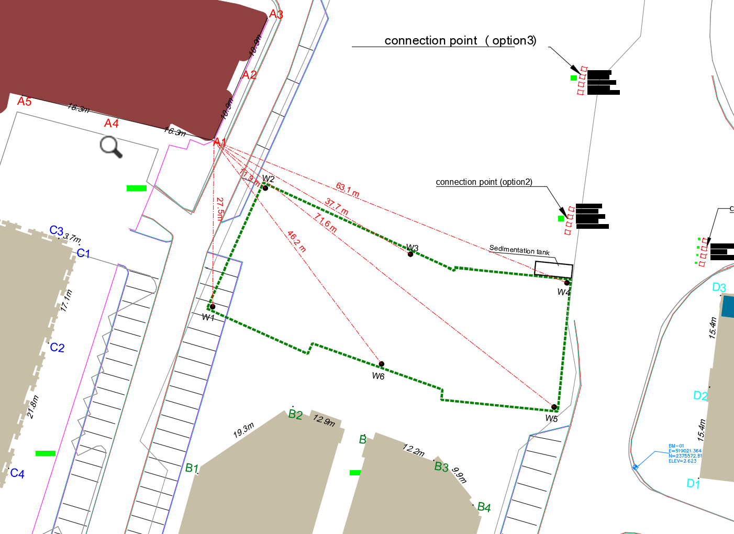

. The results are:

* For **Building A the drawdown is 2.13m** (final water level =2.13+0.90=3.03m)
* For **Building B the drawdown is 3.09m** (final water level =3.09+0.90=3.99m)

### Discharge and Pumping lines sizing

In Annex 9 (sheet “*A9 DewaterLinesSizing*”), the calculations are shown of the vertical riser pumping lines from the pumps, the horizontal up to the sedimentation tank and from there to the discharge external lines up to the Amana’s external outfall.

### Pumps

In Annex 1, the pumps selection is indicated. The used brand is for indication and any similar dewatering pump can be used.

### Filter pack

The filter pack is selected, as per the calculation of Annex 10 (sheet “*A10 FilterPack*”:

|  |  |  |  |  |  |
| --- | --- | --- | --- | --- | --- |
|  | Percentage passing |  | size |  |  |
|  | 100% |  | 9.500 | mm |  |
|  | 85% |  | 6.162 | mm |  |
|  | 50% | > | 1.390 | mm |  |
|  | 10% | > | 0.199 | mm |  |
|  | 5% | > | 0.063 | mm |  |
|  | Filter pack thickness, is taken: | | | **150** | mm |

### Well screen

*Well screen slot size*

The screen opening size is selected, as per the calculation of Annex 11 (sheet “*A11 WellScreen*”):

The Well screen slot size is taken 2 mm, which is satisfactory. It will pass the 10% of the filter at the finer limit of tolerance.

*Well wetted area screen length*

The minimum wetted area screen length is selected, as per Annex 11 sheet “*A11 WellScreen*”) calculations:

hmin=0.83m

This is the required depth of the well screen that will be beneath the final drawdown level.

it is taken 1.0m the screened part and another 0.50m the casing beneath, as is shown below and the dwg S8

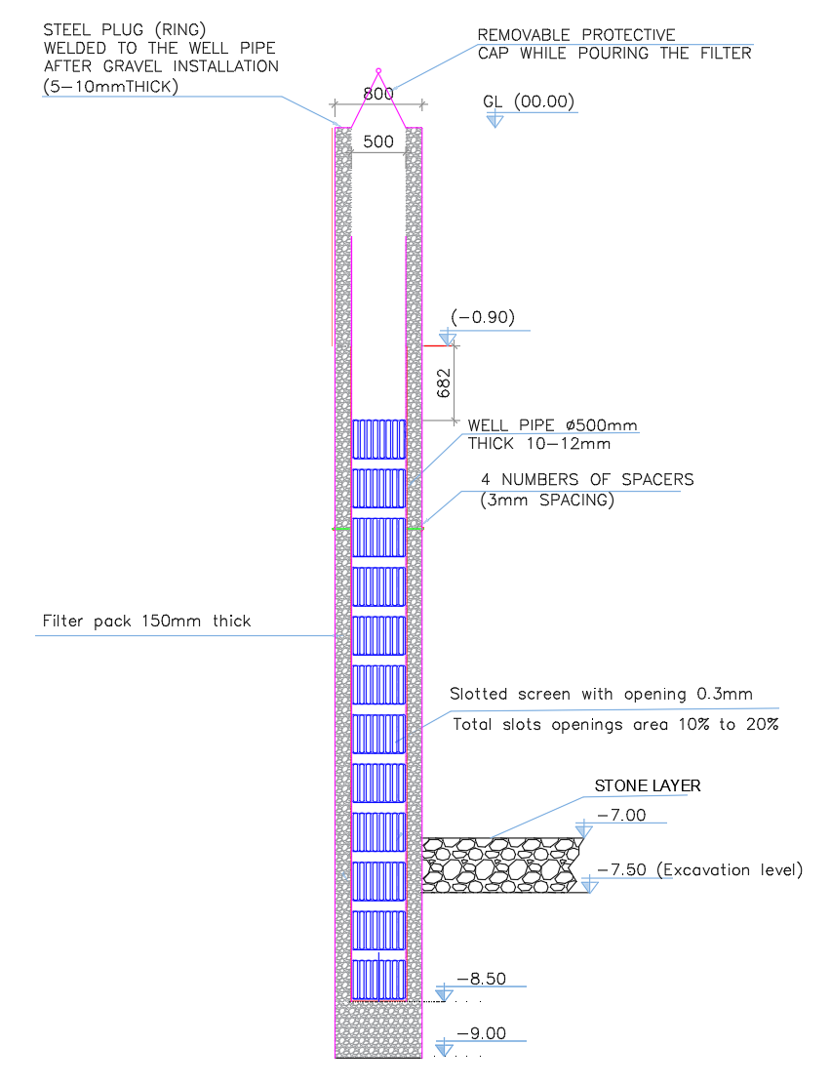;’

The well horizontal cross-section is shown in dwg S2

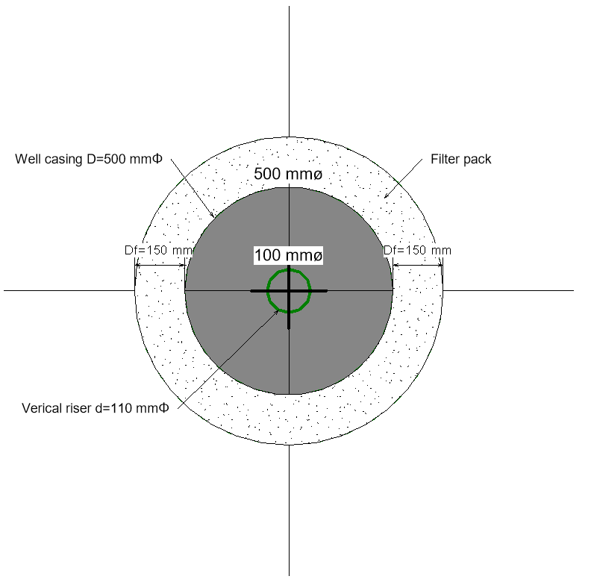

### Main Discharge Lines

The main discharge line from the sedimentation tank to the existing storm line, will be from GRP pipes of 500mm diameter, with hardness 5,000N/m2, pressure 6 bar. The minimum diameter for external lines is taken 500mm Annex 9, (Sheet “*A9 DewaterLinesSizing*”), as per Amana’s standards.

Manholes will be installed and gullies to collect the rainwater from the roads, as per the drawings, in line with Municipality’s specifications and standards, as per dwg No S07.

## **Stresses and Settlements using cohesive soil material**

* + 1. Analytical calculation of stresses and settlement

The formulas for calculating analytically the stresses at an adjacent building are presented here.

In the below figure the excavation and the initial and final (after dewatering) water levels are shown.

The final water level from the ground surface (after dewatering) at the building location is hd meters, as calculated, see above para. 2.3.5.3.

The foundation level of the building is taken either at:

-2.5m from ground level (no basement) Or at

-5.0m from ground level (one basement).

The calculation of stresses and settlements can be done, either at the middle of the layers, or at the relevant depths.

In this design, the initial underground water level (before dewatering) and the final water level (after dewatering) are taken and the effect of drawdown on the stresses and settlements is considered.

For complicity, formulas for both cases are presented here:

#### Formulas taking into account groundwater level before dewatering and after dewatering drawdown level

##### Foundation level at -2.50 m from ground level (one basement)

###### Conditions at foundation level of the building A location (depth: -2.50m)

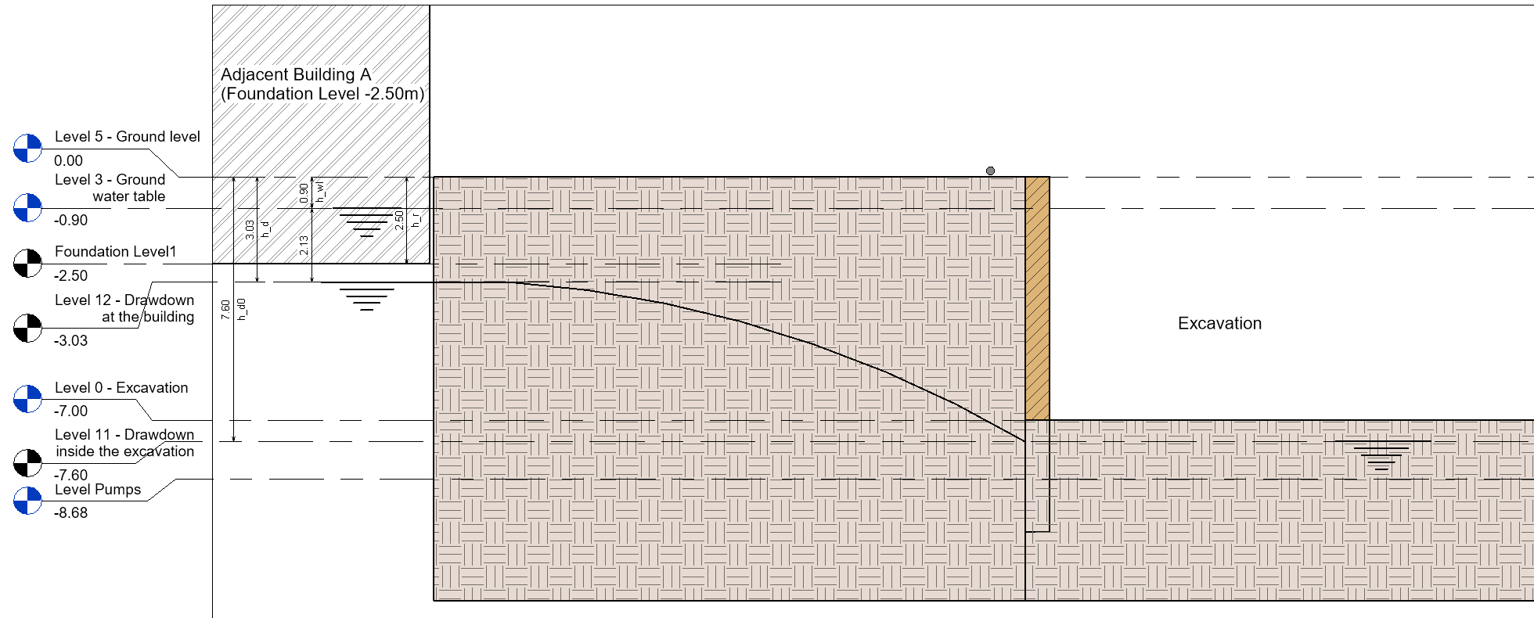

***Stresses:***

*Initial conditions (before dewatering):*

Total initial stress at building foundation depth 2.50 m

$$σ_{0@2.5m}=h_{wl}×γ_{d}+{(h}_{r}-h_{wl})× γ_{s}$$

where

$γ_{s}$ = saturated unit weight = 21 kN/m3

$γ_{d}$ = dry unit weight = 16.8 kN/m3

$γ_{w}$ = unit weight of water = 9.8 kN/ m3

Effective initial stress at depth 2.5 m

${σ'}_{o@2.5m}=σ_{0@2.5m}-{(h}_{r}-h_{wl})× γ_{w}$

*Final conditions (after dewatering and excavation);*

Total final stress at depth 2.50 m depth

$σ_{f@2.5m}=h_{d}×γ_{d}$

Effective final stress at depth 2.50 m

$${σ'}_{f@2.5m}=σ_{f@2.5m}$$

***Settlements using cohesive soil conditions:***

We estimate that beneath the foundation neighboring buildings there is proper engineering soil material. For this, the cohesive soil consolidation formulas are applied, as per:

a. Terzaghi et al. Soil Mechanics in Engineering practice para. 16.7,

b. Bowles, J. E., *Foundation Analysis and Design,* The McGraw-Hill Companies, Inc., 5th Edition, para. 2-10.4,

c. *Deep excavation Theory and Practice* Chang-Yu Ou 2006, para. 9.7)

*Area below drawdown depth*

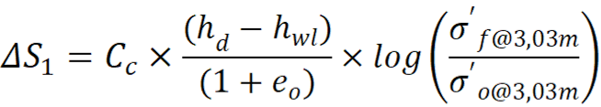

*Area above drawdown depth*

$${ΔS}_{2}=C_{c}×\frac{h_{r}}{(1+e_{o})}×log\left(\frac{{σ^{'}}_{f@2.5m}}{{σ^{'}}_{o@2.5m}}\right)$$

where

$C_{c}$ = Soil compression index = 0.07 (is taken)

0 = Soil void ratio= 0.42 (is taken)

##### Foundation level at -5.0m from ground level (one basement)

Conditions at final water level of the building A location (depth: -3.03m)

**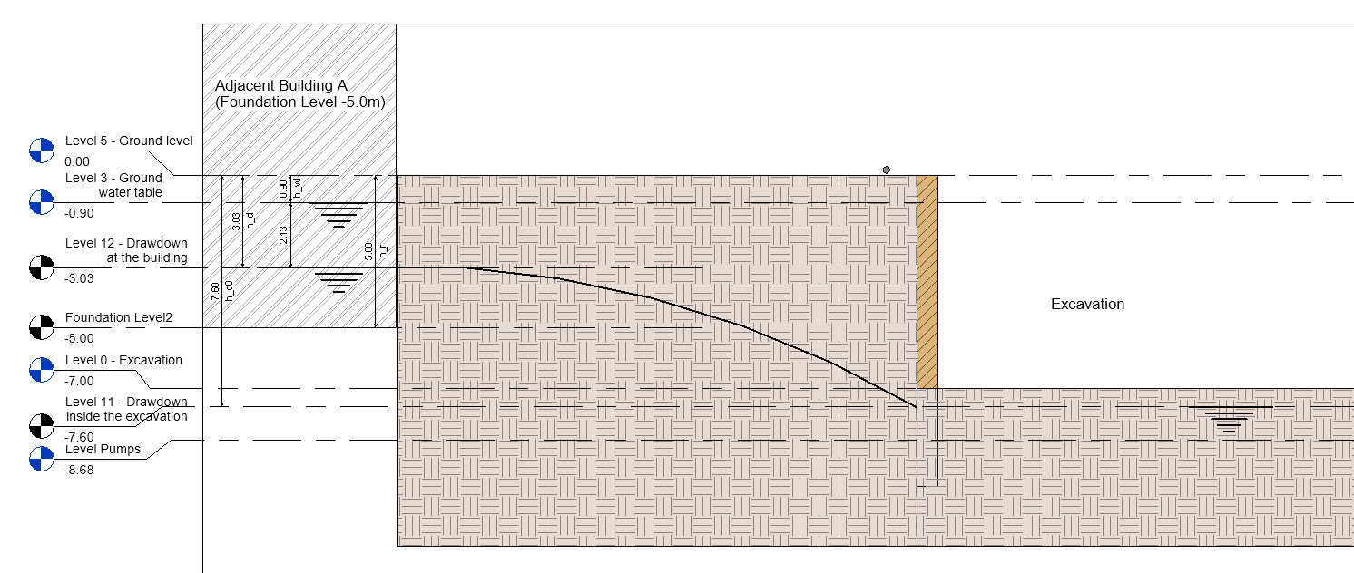**

***Stresses:***

*Initial conditions (before dewatering):*

Total initial stress at depth 3.03 m

where

= saturated unit weight = 21 kN/m3

= dry unit weight = 16.8 kN/m3

= unit weight of water = 9.8 kN/ m3

Effective initial stress at depth 3.03 m

*Final conditions (after dewatering and excavation);*

Total final stress at depth 3.03 m depth

Effective final stress at depth 3.03 m

***Settlements:***

*Area above drawdown depth*

We estimate that beneath the foundation neighboring buildings there is proper engineering soil material. It is an estimate since relevant information from the neighboring building (as built, geotechnical investigation, etc) is not available.

where

= Soil compression index = 0.07 (is taken)

e0 = Soil void ratio= 0.42 (is taken)

###### Conditions at foundation level of the building A location (depth: -5.0m)

****

***Stresses:***

*Initial conditions (before dewatering):*

Total initial stress at depth 5.0 m

where

= saturated unit weight = 21 kN/m3

= dry unit weight = 16.8 kN/m3

= unit weight of water = 9.8 kN/ m3

Effective initial stress at depth 5.0 m

→

*Final conditions (after dewatering and excavation);*

Total final stress at depth 5.0 m depth

$σ_{f@5.0m}=h_{d}×γ_{d}+{(h}_{r}-h_{d})× γ_{s}$

Effective final stress at depth 5.0 m

$${σ'}_{f@5.0m}=σ_{f@5.0m}-{(h}_{r}-h_{d})× γ_{w}$$

***Settlements using cohesive soil conditions:***

*Area above drawdown depth*

$${ΔS}_{2}=C_{c}×\frac{{(h}_{r}-h_{d})}{(1+e_{o})}×log\left(\frac{{σ^{'}}_{f@5.0m}}{{σ^{'}}_{o@5.0m}}\right)$$

where

$C_{c}$ = Soil compression index = 0.07 (is taken)

e0 = Soil void ratio= 0.42 (is taken)

###### Total settlements at foundation level of the building A location (depth: -5.0m)

The total settlements at the foundation level of Building A location is:

$${ΔS=ΔS}_{1}+{ΔS}_{2}$$

#### Formulas for the Middle of Layers

##### Foundation level at -2.5m from ground level (no basement)

###### Conditions at foundation level of the building A location (depth: -2.50m)

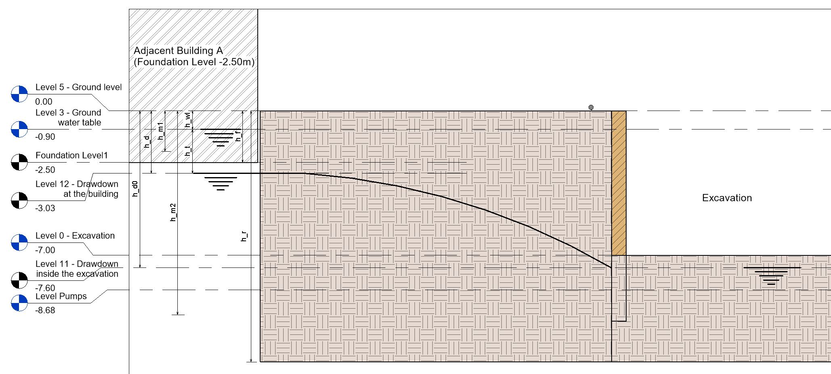

***Stresses:***

***Dewatered Section***

*Initial Stresses at Mid layer of the Dewatered Section:*

The mid layer of the dewatered section is located at a depth of *h\_m1* (m). The total and effective stresses in this location under conditions prior to dewatering are calculated below. By calculating the stresses in the middle of the layer, it is considered that the mean values of these stresses would yield a more representative result for the settlement analysis in this section of the soil.

Total initial stress at depth *h\_m1*

where

$γ_{s}$ = saturated unit weight = 21 kN/m3

$γ_{d}$ = dry unit weight = 16.8 kN/m3

$γ_{w}$ = unit weight of water = 9.8 kN/ m3

Effective initial stress at depth *h\_m1*

*Final stresses at Mid layer of the Dewatered Section:*

Total final stress at depth *h\_m1* depth

$σ_{f@h_m1}=\left(h_{WL}+\left(\frac{h_{d}-h_{wl}}{2}\right)\right)× γ_{d}$

Effective final stress at depth *h\_m1*

***Saturated Section***

*Initial Stresses at Mid-layer of the Saturated Section:*

The mid layer of the saturated section is located at a depth of *h\_m1* (m). The total and effective stresses in this location under conditions prior to dewatering are calculated below. By calculating the stresses in the middle of the layer, it is considered that the mean values of these stresses would yield a more representative result for the settlement analysis in this section of the soil.

Total initial stress at building foundation depth *h\_m1*

where

$γ_{s}$ = saturated unit weight = 21 kN/m3

$γ_{d}$ = dry unit weight = 16.8 kN/m3

$γ_{w}$ = unit weight of water = 9.8 kN/ m3

Effective initial stress at depth *h\_m2*

*Final Stresses at Mid layer of the Saturated Section:*

Total initial stress at building foundation depth *h\_m1*

Effective initial stress at depth *h\_m1*

***Settlements using cohesive soil conditions:***

We estimate that beneath the foundation neighboring buildings there is proper engineering soil material. For this, the cohesive soil consolidation formulas are applied, as per:

a. Terzaghi et al. Soil Mechanics in Engineering practice para. 16.7,

b. Bowles, J. E., *Foundation Analysis and Design,* The McGraw-Hill Companies, Inc., 5th *Edition, para. 2-10.4,*

*c. Deep excavation Theory and Practice Chang-Yu Ou 2006, para. 9.7)*

*d. Dewatering Guidelines for the City of Abu Dhabi PROJECT NO. 13-5015, Rev 1, 8/7/2014*

*Area above drawdown depth*

$${ΔS}_{1}=C_{c}×\frac{{(h}_{d}-h_{WL})}{(1+e_{o})}×log\left(\frac{{σ^{'}}_{f@h_m1}}{{σ^{'}}_{o@h_m1}}\right)$$

*Area above drawdown depth*

$${ΔS}_{2}=C_{c}×\frac{{(h}_{r}-h_{d})}{(1+e_{o})}×log\left(\frac{{σ^{'}}_{f@h_m2}}{{σ^{'}}_{o@h_m2}}\right)$$

where

$C_{c}$ = Soil compression index = 0.07 (is taken)

0 = Soil void ratio= 0.42 (is taken)

###### Total settlements at foundation level of the building A location (depth: -5.0m)

The total settlements at the foundation level of Building A location is:

$${ΔS=ΔS}_{1}+{ΔS}_{2}$$

## **Settlements using cohesionless soil conditions:**

The Schmertmann’s method is used, to compute the settlement of the neighboring foundation footings, soon after dewatering, as per reference: *Foundation Design Principles and Practices, 3nd Ed, Donald Coduto et al.*

For this method, the foundation level (lower part of the footing) of the neighboring buildings is taken -2.5m from ground level (no basement).

The bearing pressure and settlements of the buildings is calculated in the attached Excel sheet as follows:

* + For building A, Annex A4B (Excel sheet “*A4b Build A-Schemertmann*”)
  + For building C, Annex A5B (Excel sheet “*A5b Build C-Schemertmann*”)
  + For building B, Annex A6B (Excel sheet “*A6b Build B-Schemertmann*”)
  + For building D, Annex A7B (Excel sheet “*A7b Build D-Schemertmann*”) (2.5a)

For each building, the following the water table after dewatering is an input in the Excel sheet.

Based on the dimensions of the footing (raft foundation is considered here) and the load of the building on the foundation and the duration of the effect (1 year is considered herewith).

The loads and raft footing dimensions per building are calculated in Annex A4B (Excel sheet “A8 LoadsNeighborBuildings” )

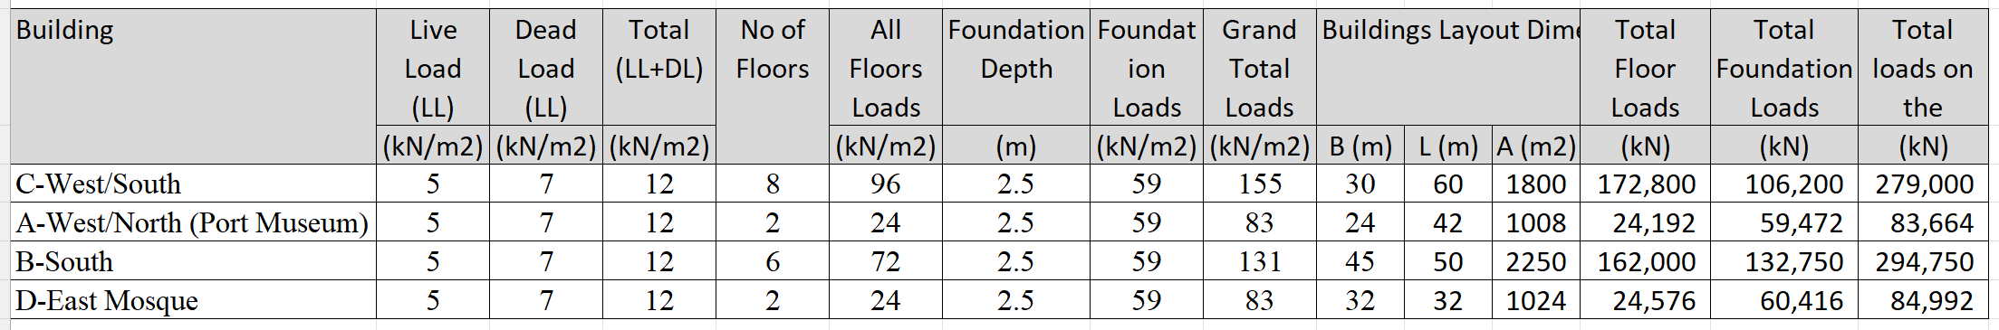

Below, the methodology for building A-West/North (Port Museum) is presented, while for all the buildings the calculations are similar and are included in the Attached Excel sheet.

The bearing pressure of the building on the bottom of its foundation is 42,336 kN

As per as per the Geotechnical report para 7.1, ACES 11/3/2023

SPT= 30 (average at 7.5m depth)

N60 = 32

Silty Sand is the main soil layer.

Correlation between CPT and SPT

As per (*O. Kara & Z. Gündüz, 2nd International Symposium on Cone Penetration Testing, Huntington Beach, CA, USA, May 2010*)

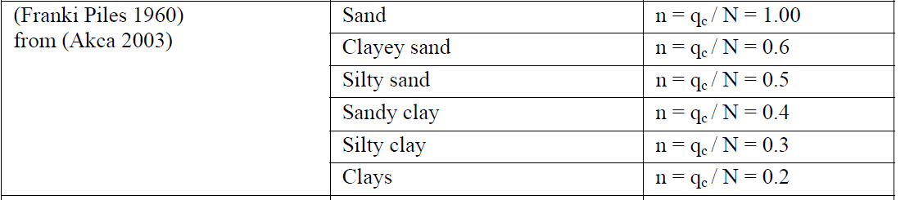

Also, relevant correlation is included in *Foundation Engineering Handbook, Braja M. Das, 2011, para. 1.8.2, Table 1.10*

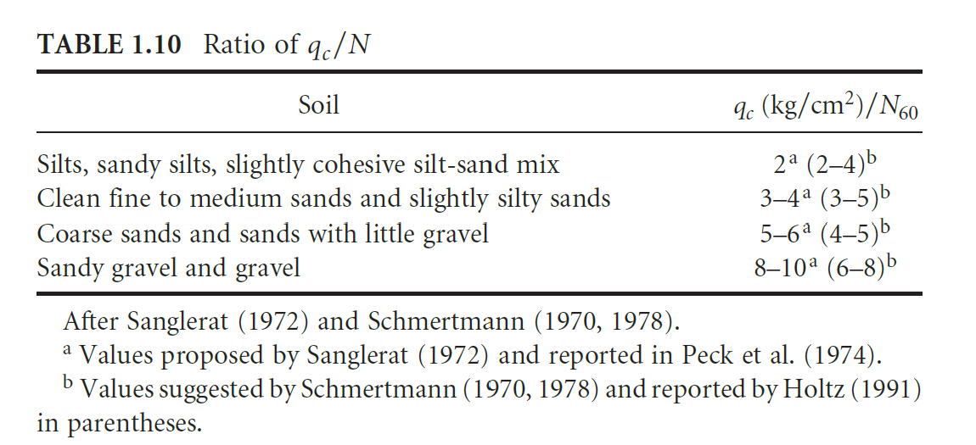

It is taken:

n=qc/N=0.3 (MPa) -> qc = Nx0.3 = 30x0.3=9 MPa = 9,000 kPa

Es calculation

From *Foundation Design Principles and Practices, 3nd Ed, Donald Coduto et al., Table 4.8*:

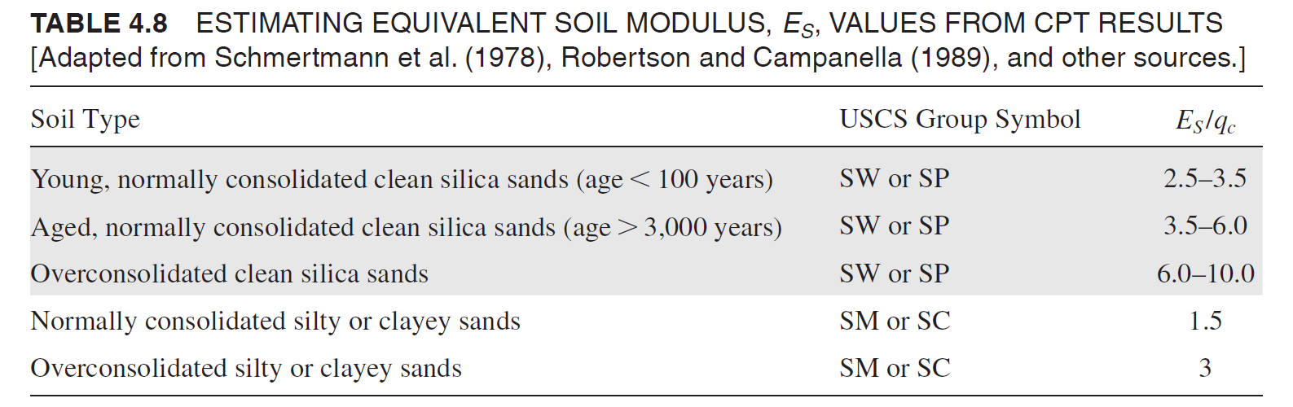

Es/qc = 1.5 -> Es = 1.5x9,000 kPa = 13,500 kPa

The soil beneath the footing is separated into layers, e.g. of 1.50m thick.

For each layer the soil modulus is calculated, as per above, based on the information provided from the Geotechnical report (para 7.1, ACES 11/3/2023). The calculations are included in the Schemertmann Excel sheets (see above 2.5a sheets)

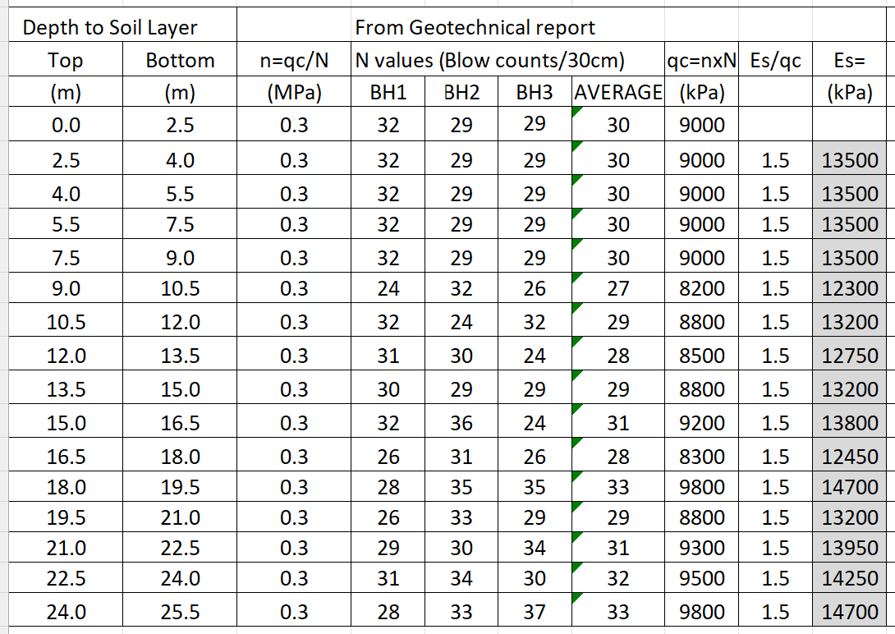

Optionally, the formulas provided with the Geotechnical report, ACES 11/3/2023, Appendix G, can be used:

From SPT

Normal sand:

Es = 1000 x N60 (kPa)

Silts, sandy silts or Clay silts

Es = 330 x N60 +1800

Gravelly Sand

Es = 1300 x N60 +7200

The main soil type in the project is silty sand. For N average 30, then

Es=330 x 30 + 1800 = **11,700 kPa,** which is similar to the calculated values in

From CPT

Square footing

Es = 2.5 x qc (kPa)

Strip footing

Es = 3.5 x qc (kPa)

Depth of influence (para. 8.2 of *Donald Coduto et al)*

For Square (SQ) and Circular Footings (CIR), L/B=1, depth of influence 2B

L/B >= 10, Continuous Footing, depth of influence 4B

1 < L/B <10, Rectangular Footing, depth of influence 2B

Di = D + 2B = 2.5 + 2x24 = 50.5 m

It is taken 25m, as per the geotechnical report provided boreholes depths.

Bearing pressure of buildings at foundation level, as per *Foundation Design Principles and Practices, 3nd Ed, Donald Coduto et al.,* Para. 6.3:

$$q=\frac{P+W_{f}}{A}- u_{D}$$

where

q = bearing pressure

P = vertical. column load

Wf = weight of foundation, including the weight of soil above the foundation, if any

A = base area of foundation B2 for square foundations or BxL for rectangular foundations

uD = pore water pressure at bottom of foundation (i.e., at a depth D below the ground surface).

Virtually all shallow foundations are made of reinforced concrete, so Wf is computed using a unit weight for concrete, gc, of 23.6 kN/m3 (150 lb/ft3).

The pore water pressure at bottom of foundation uD for buildings A, is:

Before dewatering:

Hw0 = 0.90m

uD = (2.50-0.90) x γw = 1.60m x 9.80 kN/m3 = 15.68 kN/m2

q = 42-15.68 = 26.32 kN/m2

After dewatering and final drawdown of -3.03m, the whole foundation (-2.50m) will be out of the water:

Hw1 = 2.50m

uD = (2.50-2.50) x γw = 0m x 9.80 kN/m3 = 0

q = 42-0 = 30 kN/m2

Thus, after the dewatering will be an additional bearing load of:

qadd = 42-14.32= 27.68kN/m2

For this load, the settlements of the building will be calculated.

**Buildings A Settlements**

Building total load 42,336 kN

Vertical effective stress at depth *D* below the ground surface

*σ’zd* = γ*D* – *u*

As per and *Donald Coduto et al,* Para. 8.2, Eq (8.11), (8.16), (8.12) and (8.13)

$$I_{εp}=0.5+0.1\sqrt{\frac{q-{σ'}_{zD}}{{σ'}_{zp}}}$$

For rectangular footing:

$$I_{ε}=I_{εs}+0.111\left(I_{εc}-I_{εs}\right) \left(\frac{L}{B}-1\right)$$

Where $I_{εs}$ for square footing:

$I_{εs}=0.1+\left(\frac{z_{f}}{B}\right)\left(2I_{εp}-0.2\right), for \frac{z_{f}}{B}<0.5$

and

$I_{εs}=0.667I_{εp}\left(2-\frac{z_{f}}{B}\right), for 0.5 ≤\frac{z_{f}}{B}<2$

And $I_{εc}$ for continuous footing:

$I_{εc}=0.2+\left(\frac{z_{f}}{B}\right)\left(I_{εp}-0.2\right), for \frac{z_{f}}{B}<1$

and

$I_{εc}=0.333I_{εp}\left(4-\frac{z_{f}}{B}\right), for 1 ≤\frac{z_{f}}{B}<4$

Settlements:

$$δ={C1C2C3\left(q-σ_{zD}^{'}\right)\sum{\frac{I_{ε}H}{E_{s}}} }_{}$$

$$δ=\sum{S_{t}H}$$

Where strain St

and H is the thickness of each layer.

Shape factors:

$$C_{1}=1-0.5\left(\frac{{σ'}_{zD}}{q-{σ'}_{zD}}\right)$$

$C_{2}=1+0.2 \log\left(\frac{t}{0.1}\right)$ for $t≥0.1$ year

$$C_{3}=\max\left\lfloor 1.03-0.03\left(\frac{L}{B}\right), 0.73\right\rfloor$$

where

*C*1 = depth factor

*C*2 = secondary creep factor

*C*3 = shape factor

###### **Foundation level at -5.0m from ground level (one basement)**

Conditions at final water level of the building A location (depth: -3.03m)

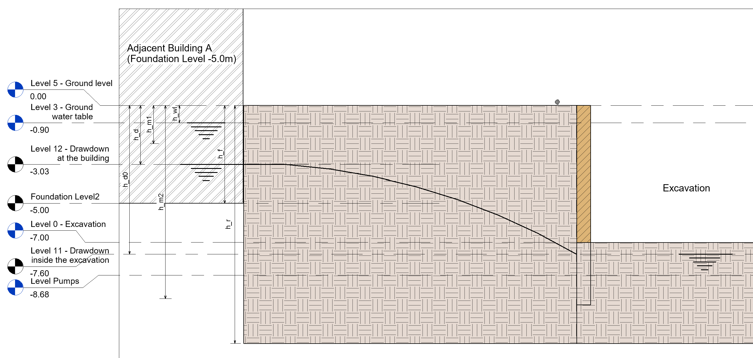

***Stresses:***

*Initial conditions (before dewatering):*

Total initial stress at depth 3.03 m

where

= saturated unit weight = 21 kN/m3

= dry unit weight = 16.8 kN/m3

= unit weight of water = 9.8 kN/ m3

Effective initial stress at depth 3.03 m

*Final conditions (after dewatering and excavation);*

Total final stress at depth 3.03 m depth

Effective final stress at depth 3.03 m

***Settlements:***

*Area above drawdown depth*

We estimate that beneath the foundation neighboring buildings there is proper engineering soil material. It is an estimate since relevant information from the neighboring building (as built, geotechnical investigation, etc) is not available.

where

= Soil compression index = 0.07 (is taken)

e0 = Soil void ratio= 0.42 (is taken)

###### Conditions at foundation level of the building A location (depth: -5.0m)

****

***Stresses:***

*Initial conditions (before dewatering):*

Total initial stress at depth 5.0 m

where

= saturated unit weight = 21 kN/m3

= dry unit weight = 16.8 kN/m3

= unit weight of water = 9.8 kN/ m3

Effective initial stress at depth 5.0 m

→

*Final conditions (after dewatering and excavation);*

Total final stress at depth 5.0 m depth

$σ_{f@5.0m}=h_{d}×γ_{d}+{(h}_{r}-h_{d})× γ_{s}$

Effective final stress at depth 5.0 m

$${σ'}_{f@5.0m}=σ_{f@5.0m}-{(h}_{r}-h_{d})× γ_{w}$$

***Settlements:***

*Area above drawdown depth*

$${ΔS}_{2}=C_{c}×\frac{{(h}_{r}-h_{d})}{(1+e_{o})}×log\left(\frac{{σ^{'}}_{f@5.0m}}{{σ^{'}}_{o@5.0m}}\right)$$

where

$C_{c}$ = Soil compression index = 0.07 (is taken)

e0 = Soil void ratio= 0.42 (is taken)

###### Total settlements at foundation level of the building A location (depth: -5.0m)

The total settlements at the foundation level of Building A location is:

$${ΔS=ΔS}_{1}+{ΔS}_{2}$$

## Displacement at two Nodes areas, using analytical cohesion soil model calculations and numerical model as well.

The displacements at the 2 nodes (F & B) at the buildings area also examined, as indicated below.

The calculations contacted analytically and numerically as well.

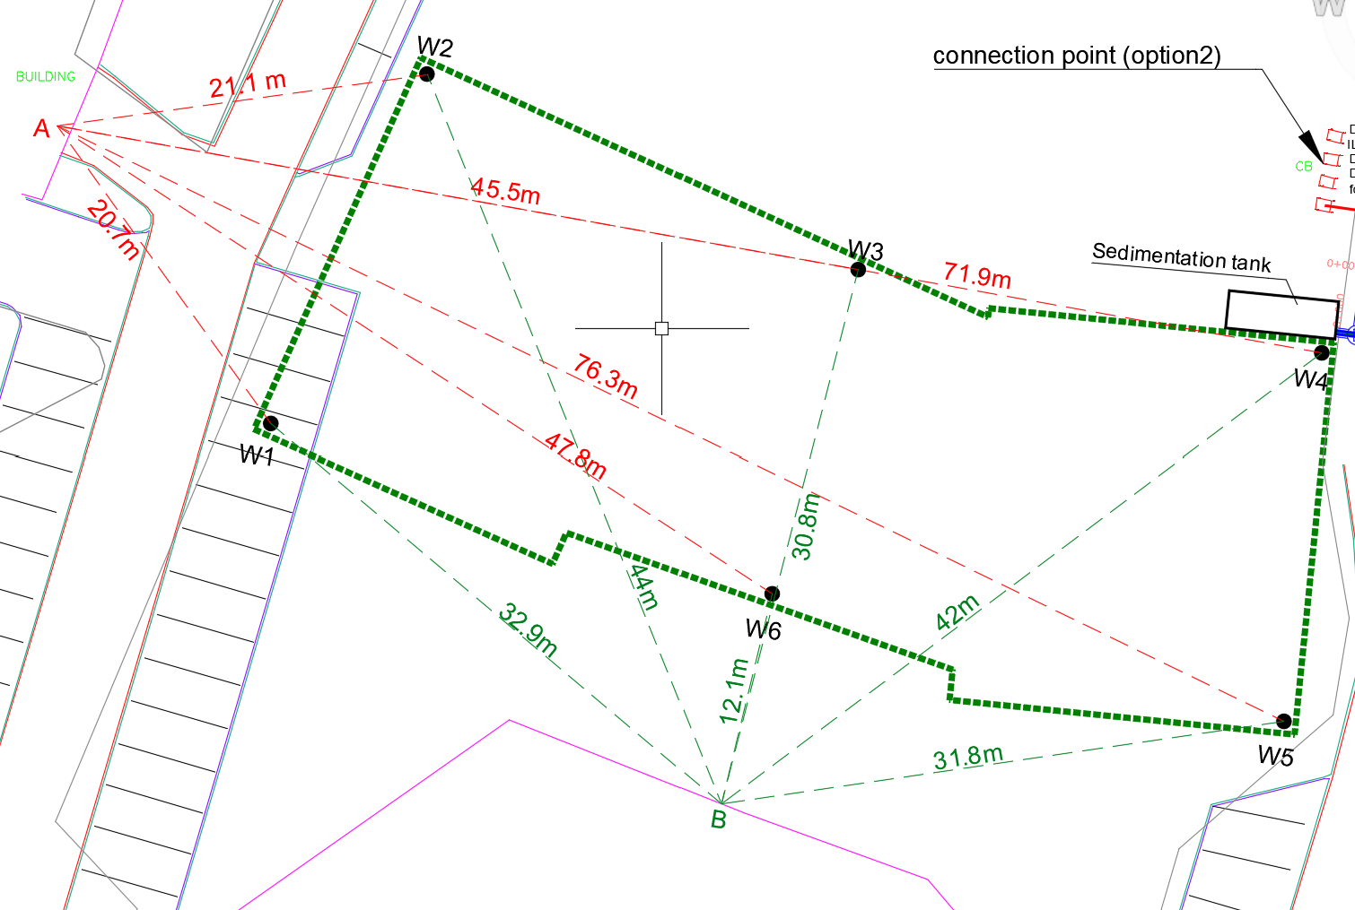

### Excavation and dewatering numerical modeling

CONSULTANT applied also numerical calculations regarding the settlement, using the PLAXIS software for the numerical modeling of the excavation (see results in Annex 6).

To implement the model, various assumptions have been made, as surface load, secant piles rigid sheet wall.

Additional load from the neighboring structures applied at the foundation level.

The Plaxis numerical analysis simulates the process into construction stages with relevant water reduction, including the supporting system and wall anchors to restrict the settlements of the surrounding buildings.

#### Surface Loading

The following additional surface loading considered to the exterior to the excavation areas, on a perimeter of 10m wide, to reflect any external loading:

* West: 40 kN/m2 (5kN/m2 x 8floors)
* South: 30 kN/m2 (5kN/m2 x 6floors)
* East: 20 kN/m2 taken
* North: 20 kN/m2 taken

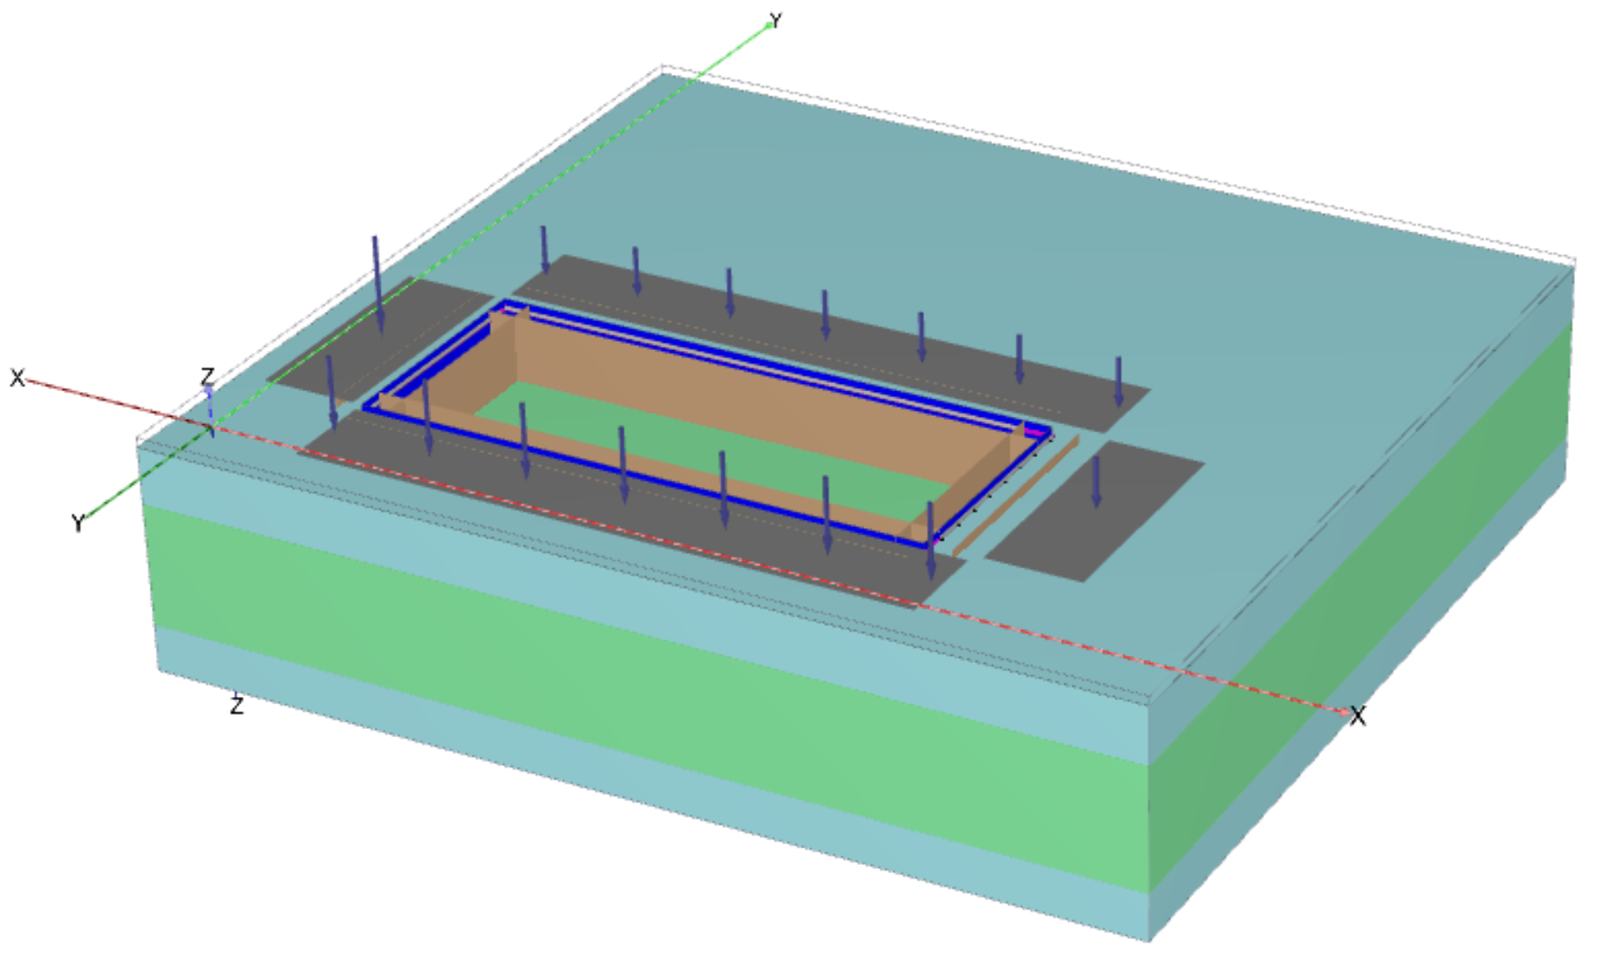

#### Type of Analysis:

Groundwater flow with time tending to infinity, it is similar to steady state type

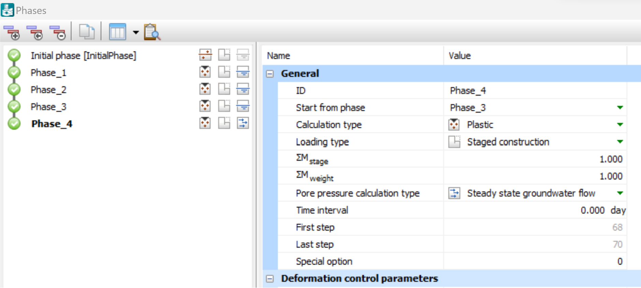

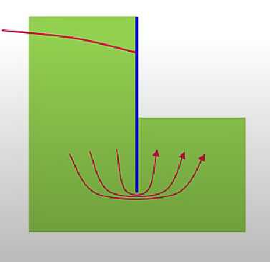

#### Pumping Wells

Six (6) wells considered, with 336 m3/day extraction capacity each (inline with the Excel sheet calculations). The minimum possible head in the well considered is ***hmin = - 7.5m***. When the groundwater head reduces below the *hmin* level no further extraction will occur. This figure is required from the software.

Flow direction X-X:

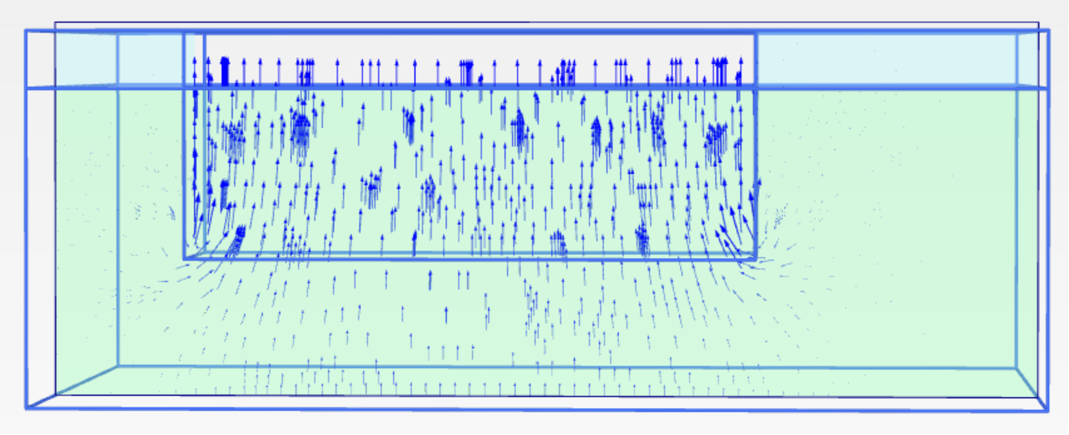

Flow direction Y-Y:

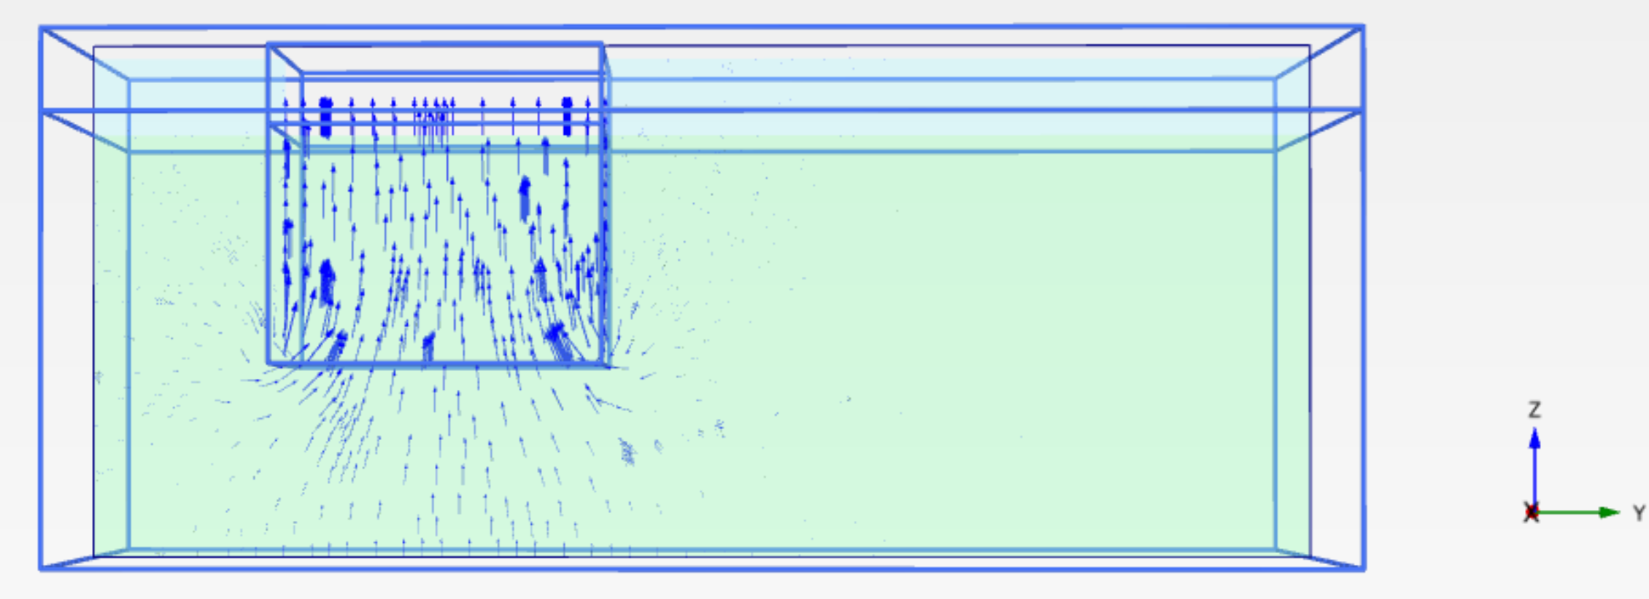

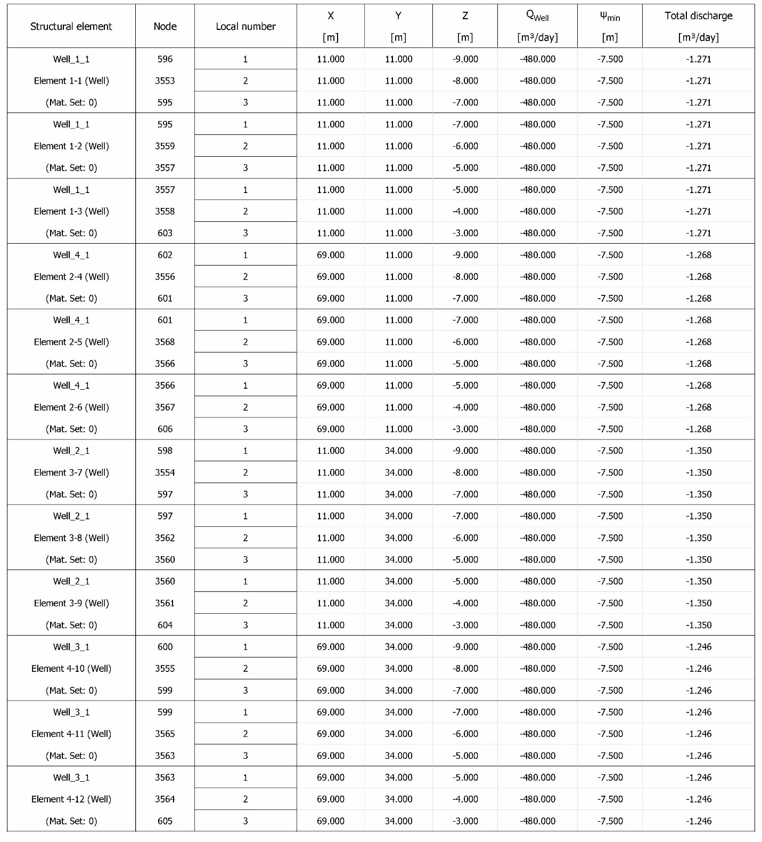

#### Displacement results in a cross section at X and Y directions

PLAXIS groundwater head calculations give:

Groundwater head in X-X direction:

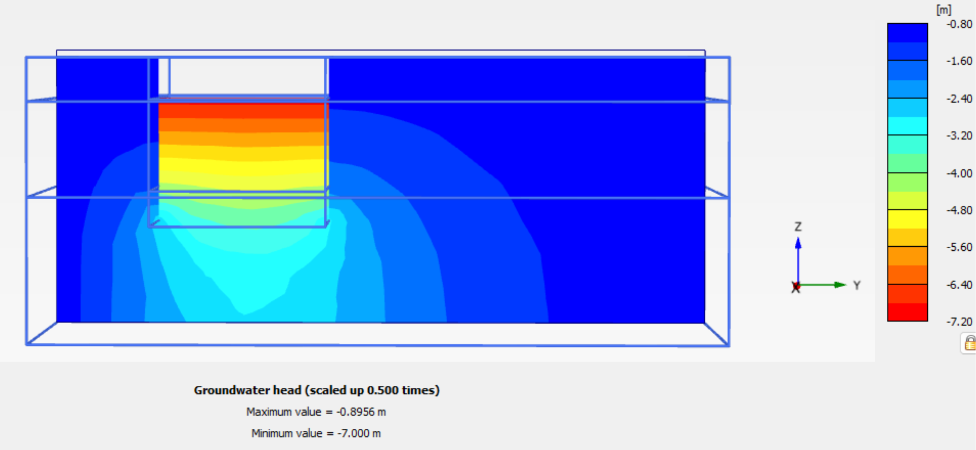

Groundwater head in Y-Y direction:

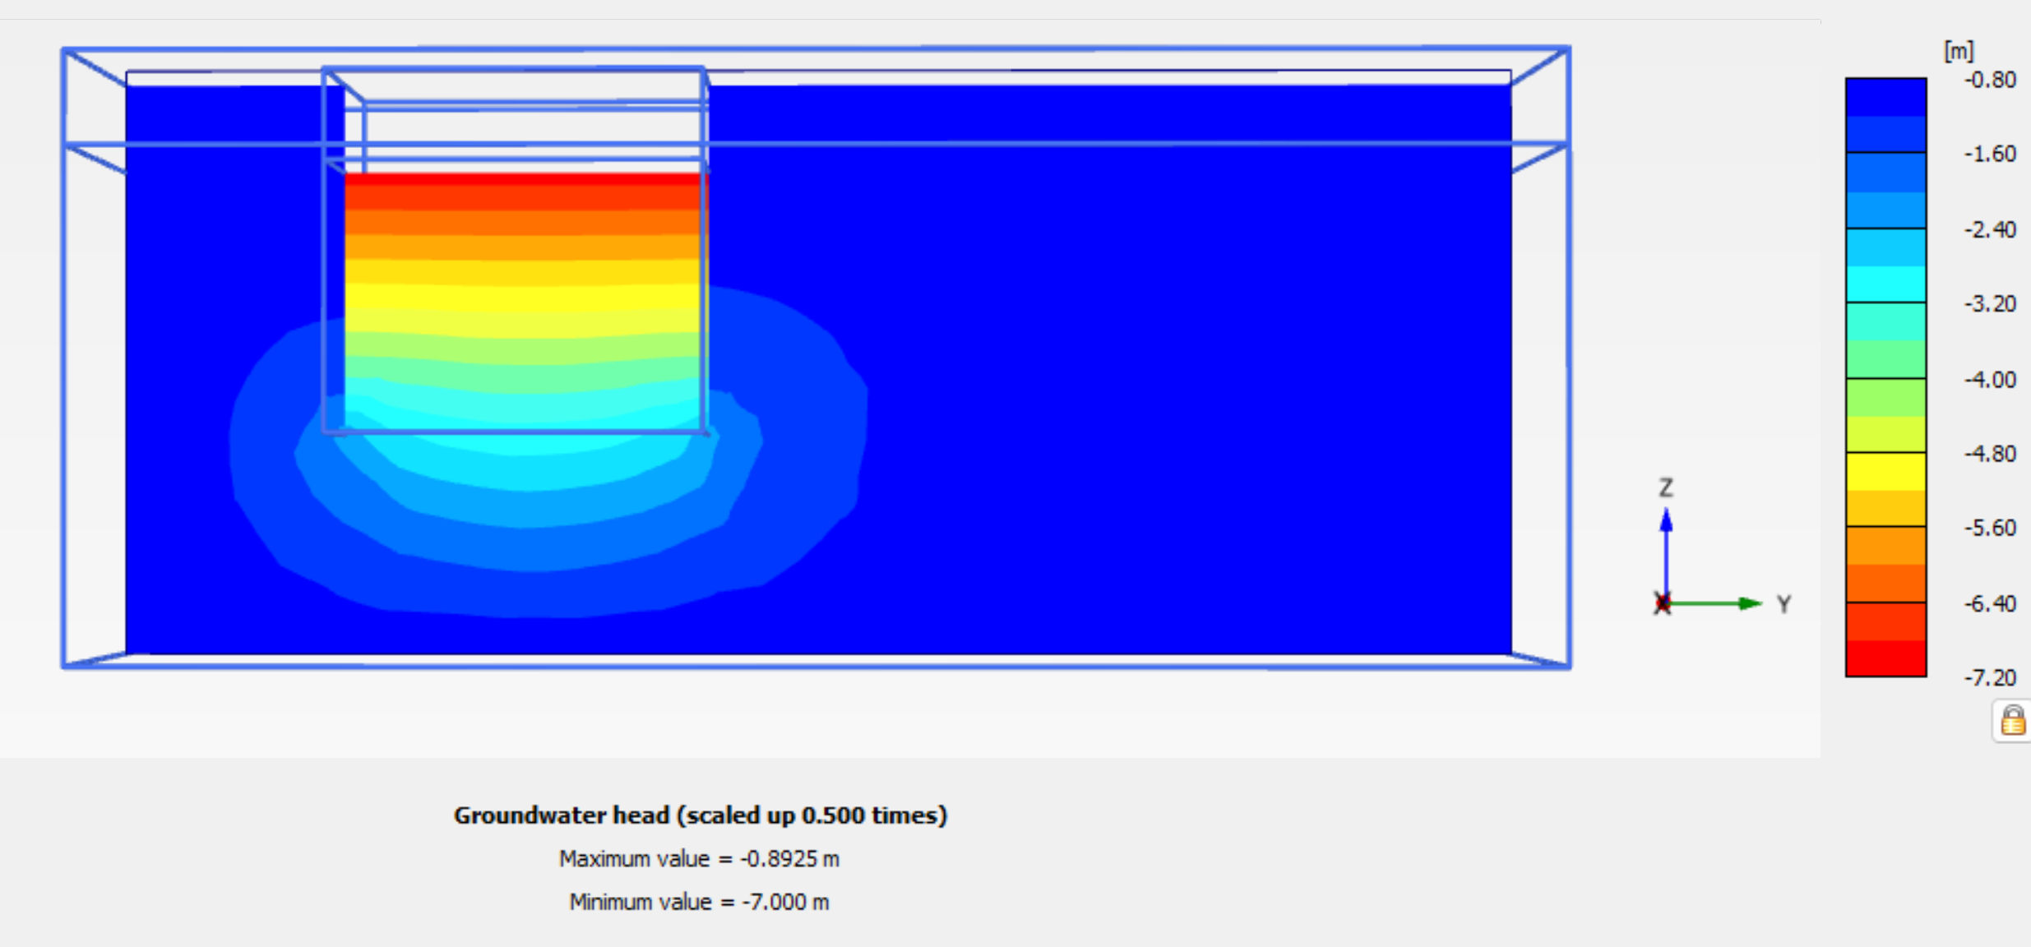

#### Displacement results in a cross section at X and Y directions

#### Only deformations due to dewatering effect are considered within the project area. Surface loading is considered only outside the project boundaries due to existing buildings loading and is taken into account for the effective water pressure effects.

The displacements in a cross section in X direction, is shown below:

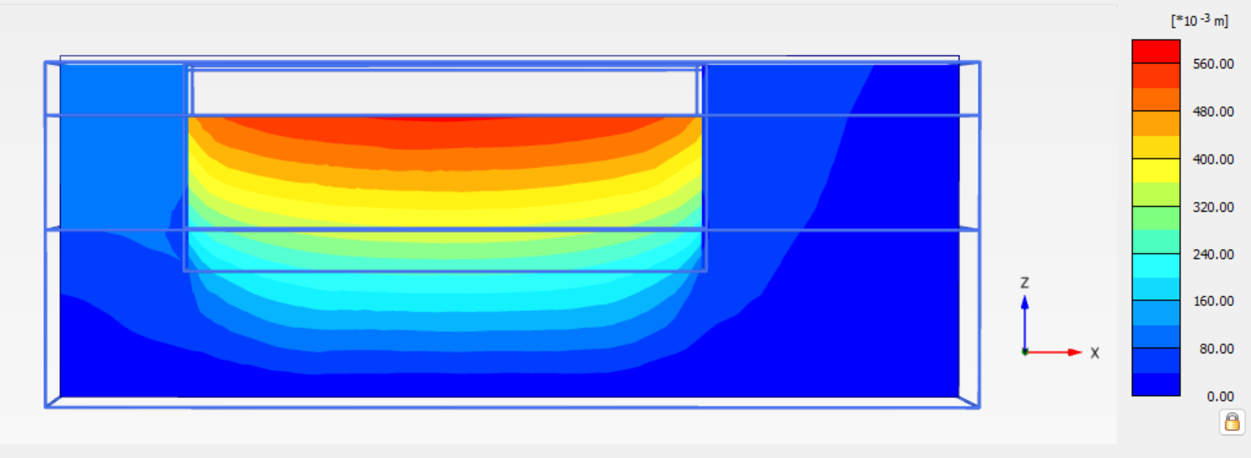

And considering the buildings location

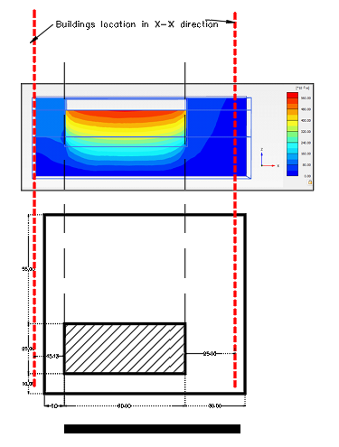

The displacements in cross section in Y direction, are shown below:

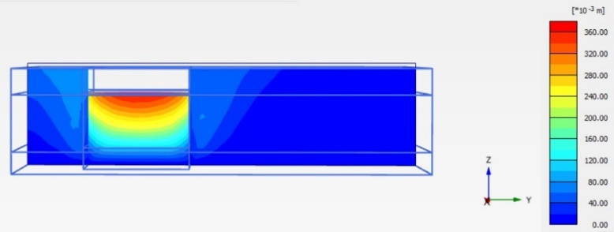

And considering the buildings location

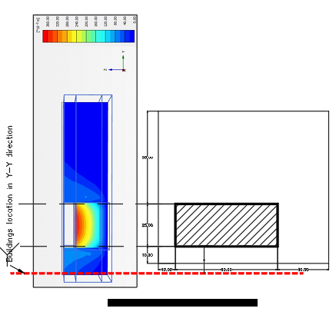

##### Numerical calculation of settlements

###### Displacements at Point F (12936):

#### Only deformations due to dewatering effect are considered within the project area. Surface loading is considered only outside the project boundaries due to existing buildings loading and is taken into account for the effective water pressure effects.

The settlement calculations in the nearest buildings is sufficient

**West** Point F (West side) at Heritage building foundation: (-5.00, 22.94, -5.55)

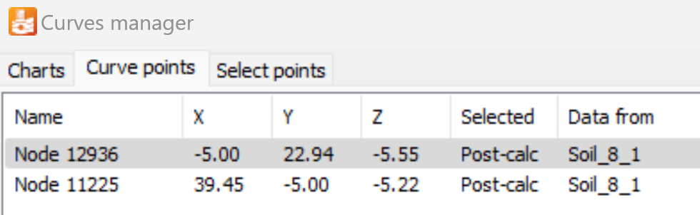

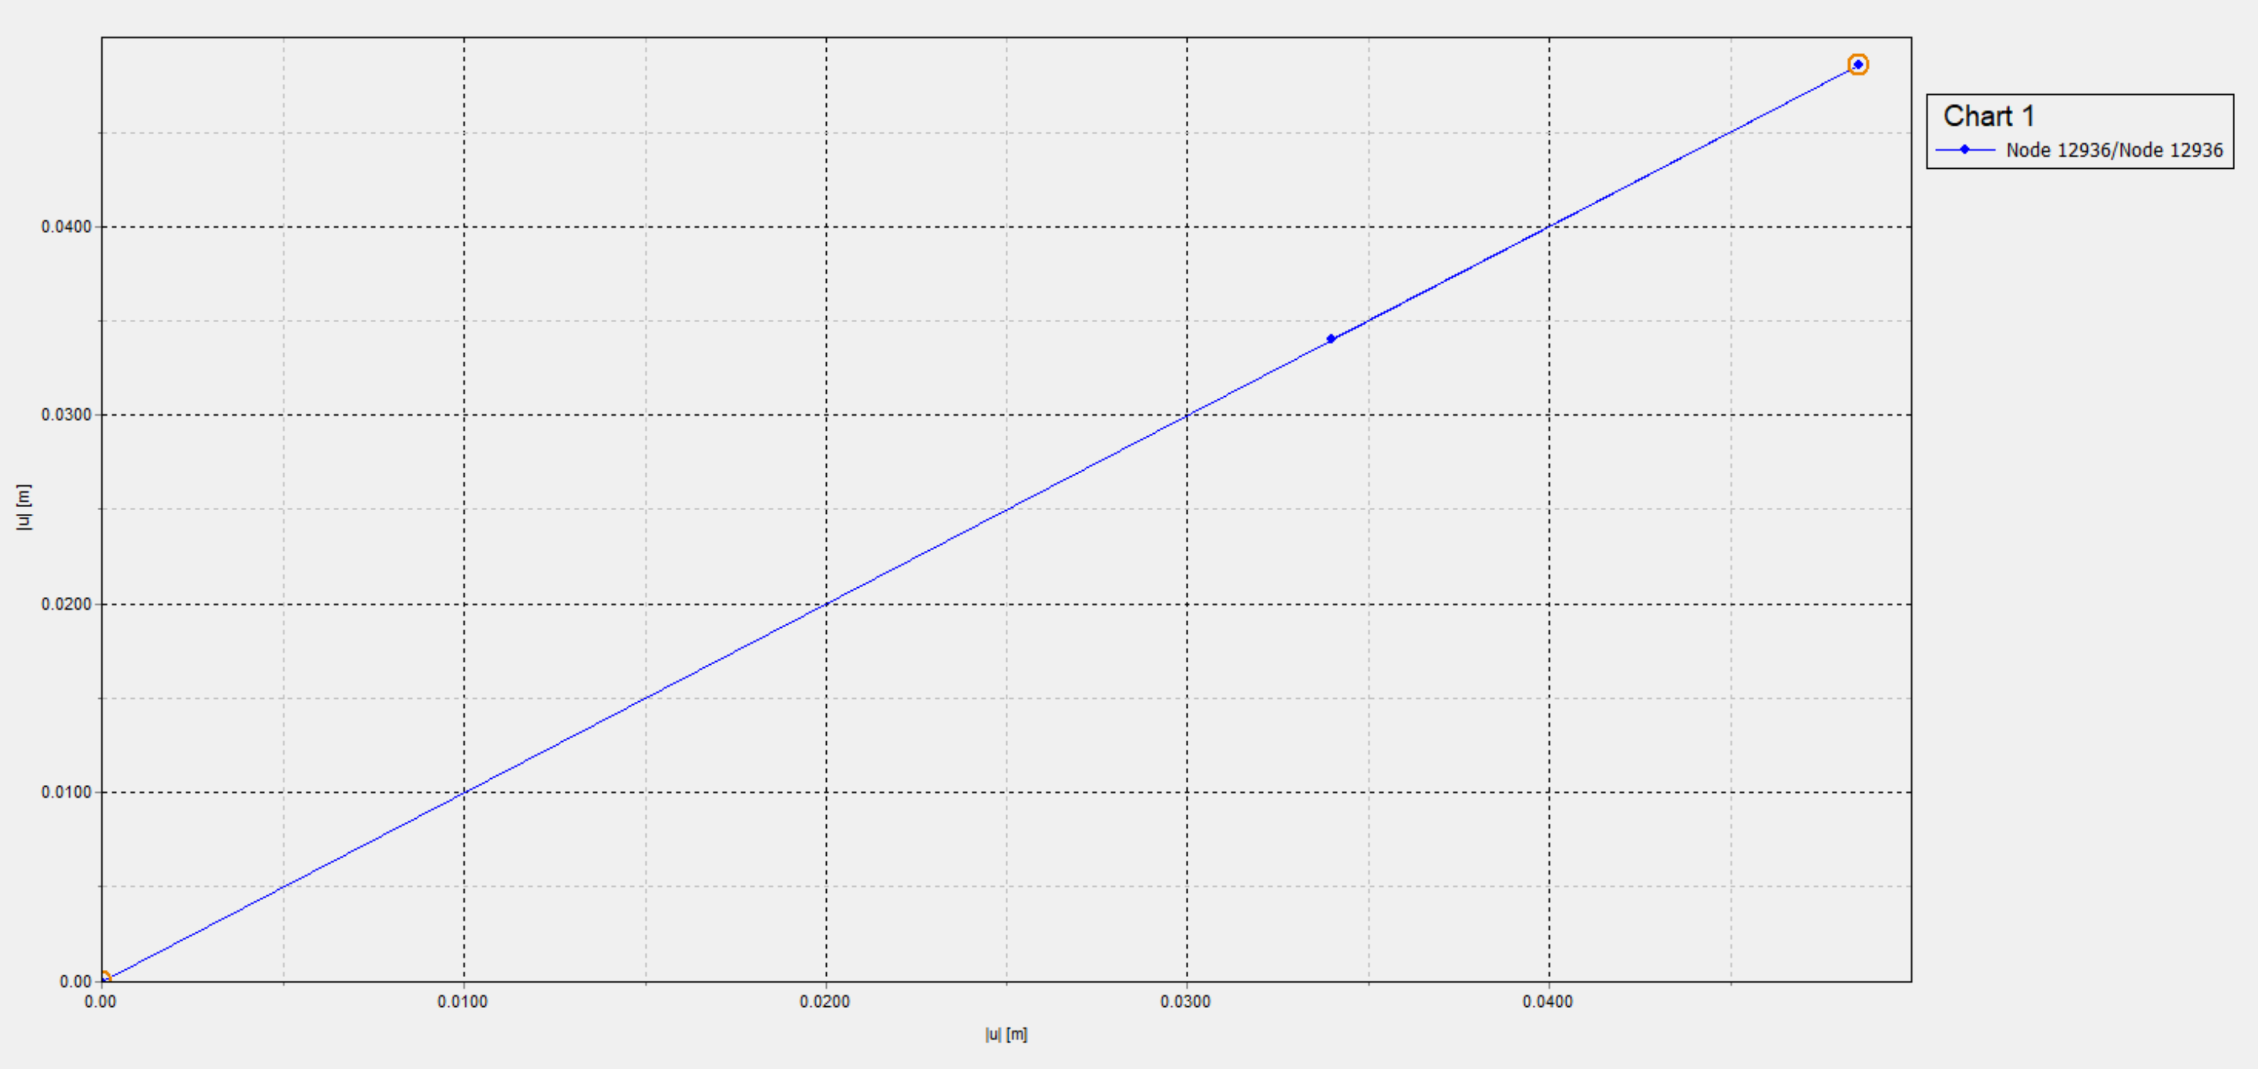

###### Displacements at Node B (11225) (South side building):

**South** Point B at Heritage building foundation: (39.45, -5.00, -5.22)

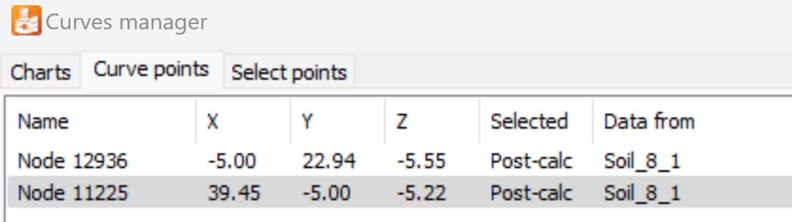

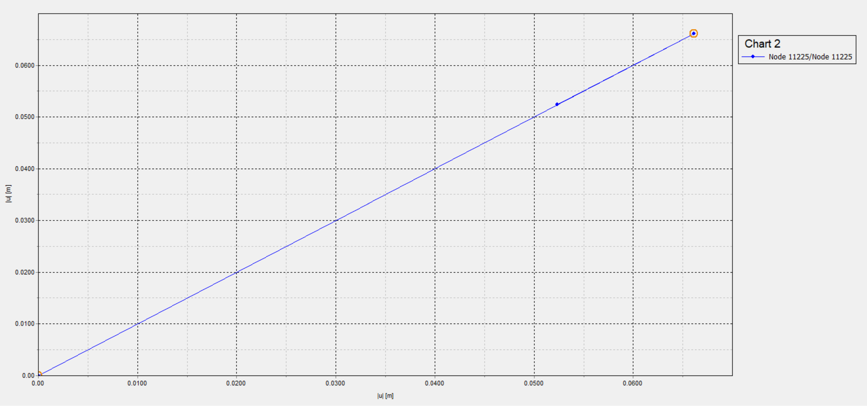

* + - * 1. Soil material used in Plaxis

The main soil material, as per the geotechnical investigation is silty sand, all landfill will be removed.

The relevant data used in the program, are:

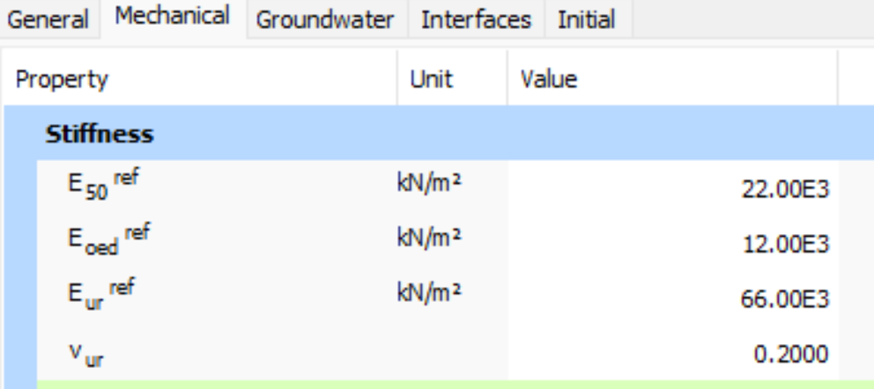

Also the below graph from the Plaxis, shows additional characteristics of Silty Sand material (hardening soil)

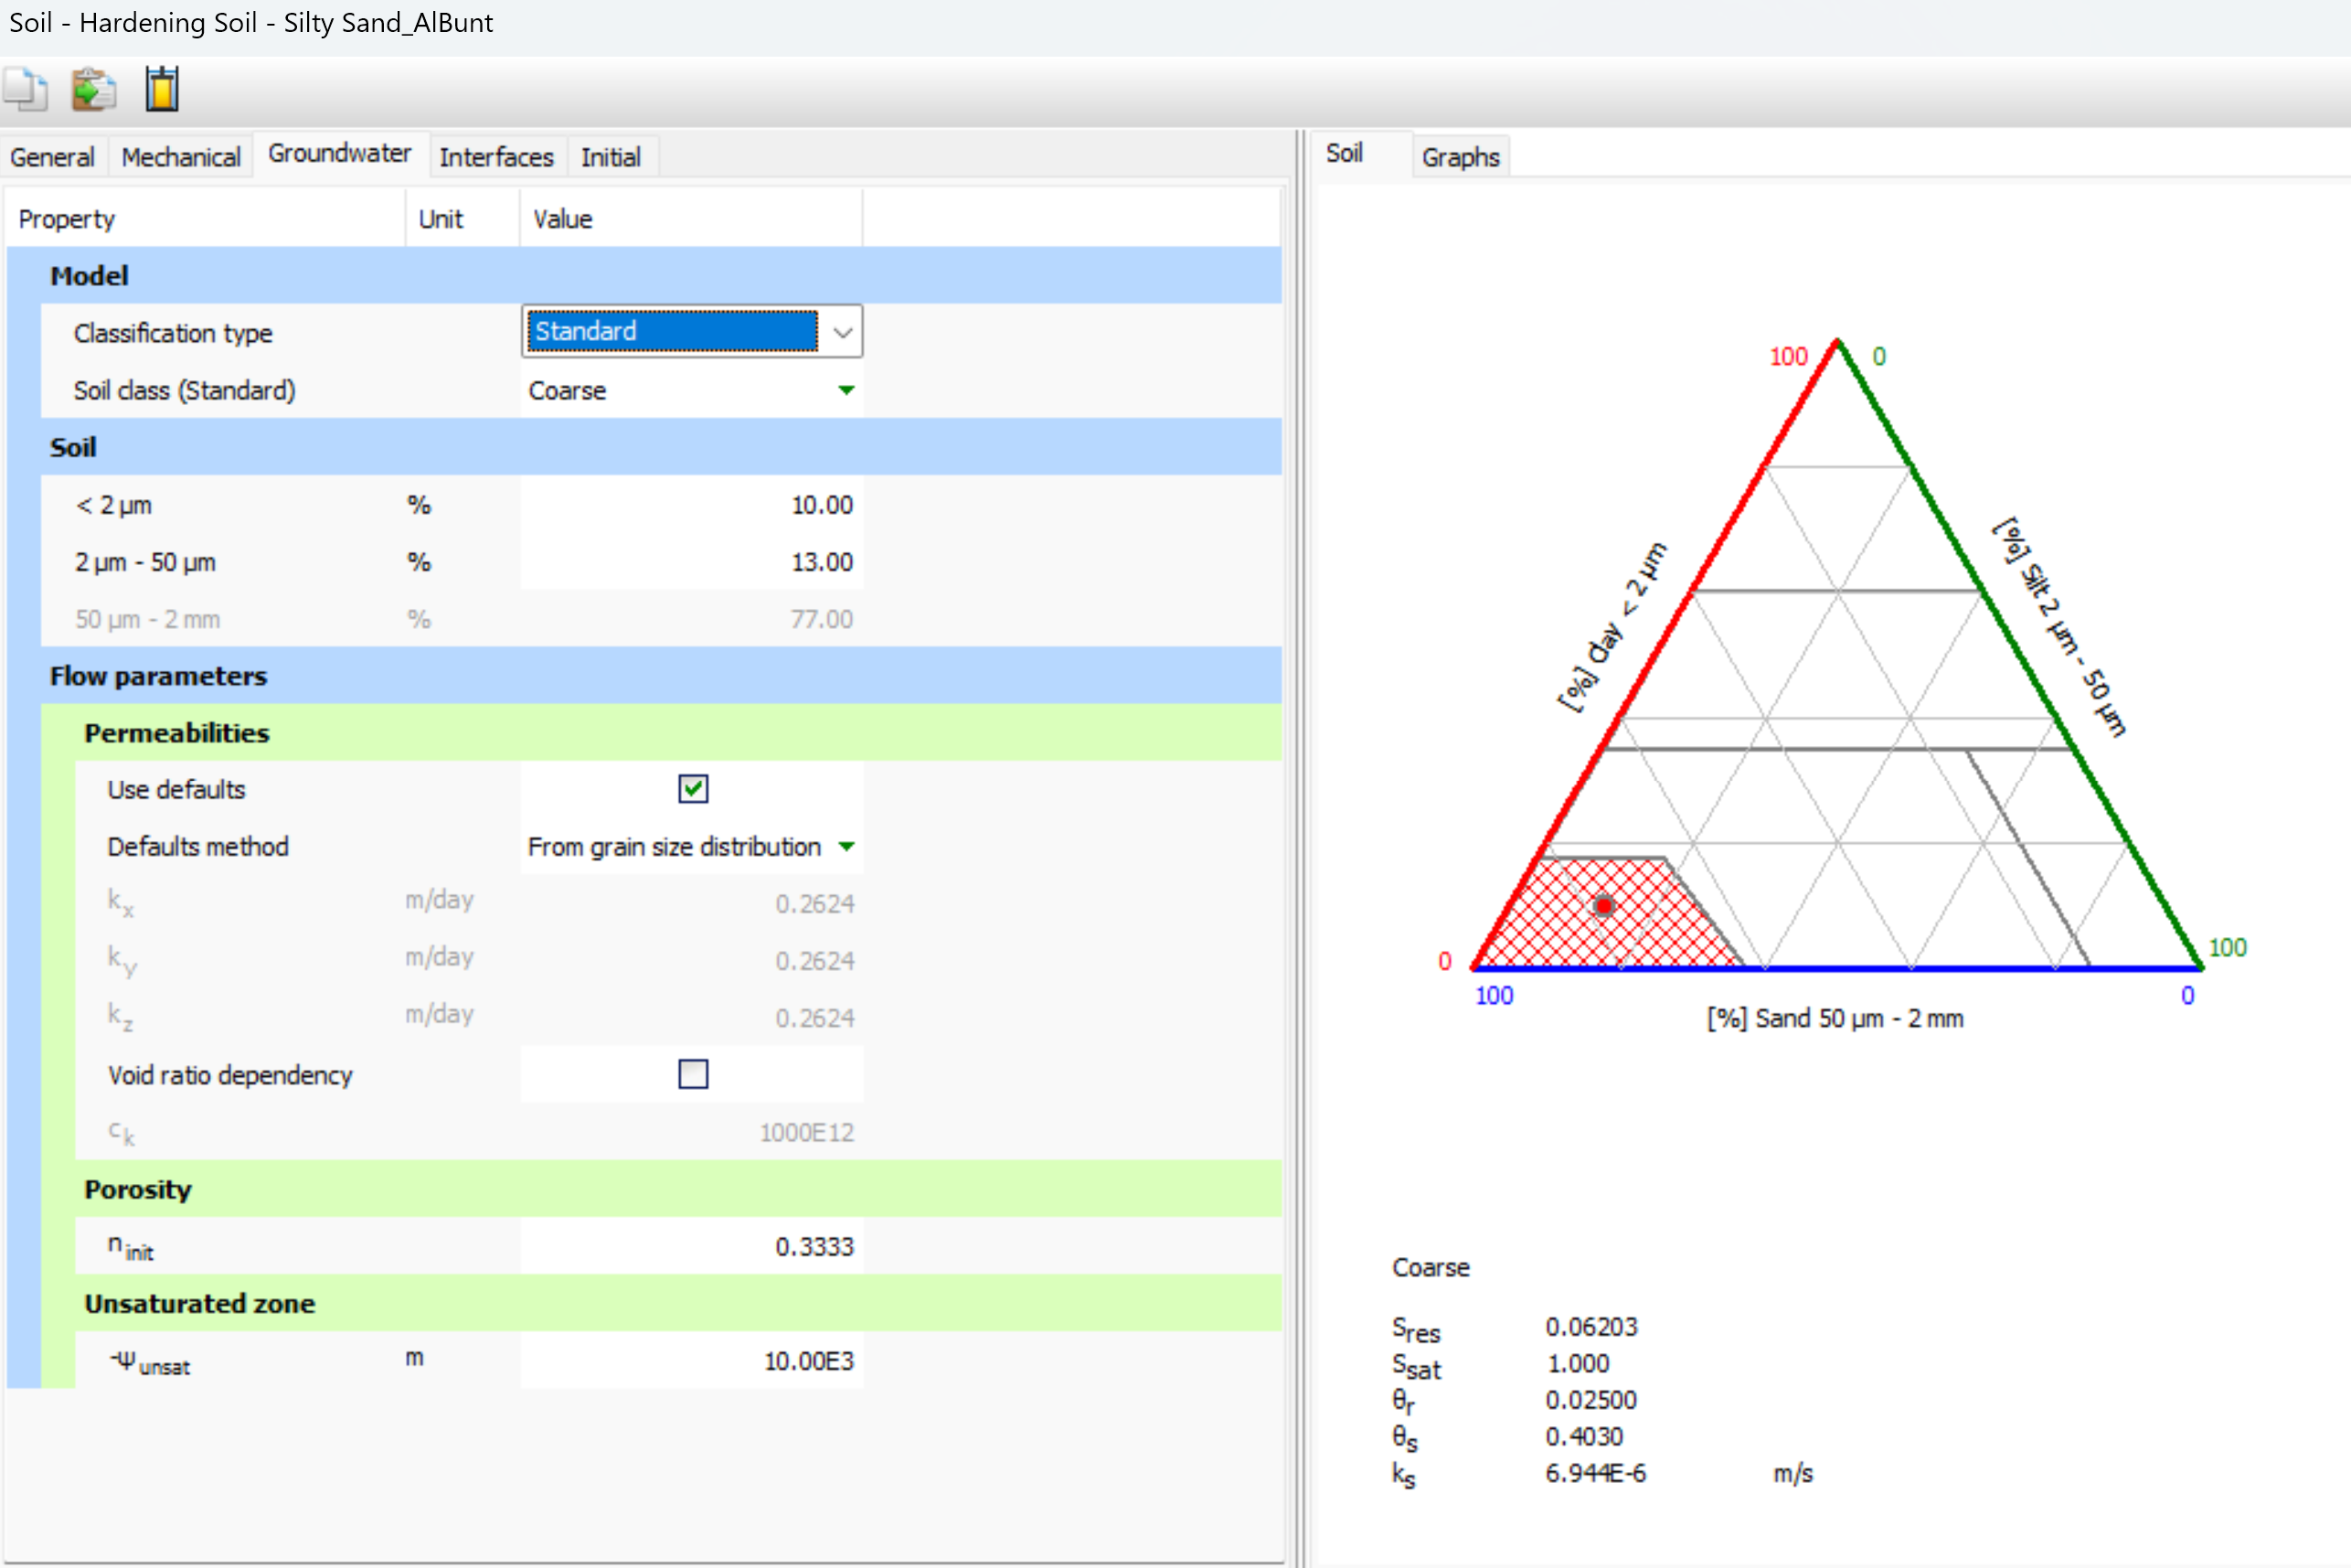

## Maximum Displacement and Differential Displacements at buildings Nodes

The maximum settlement at the foundation of neighboring buildings points is:

**Building A, Annex A4c (Excel sheet “A4c Build A-SettlementSum”)**

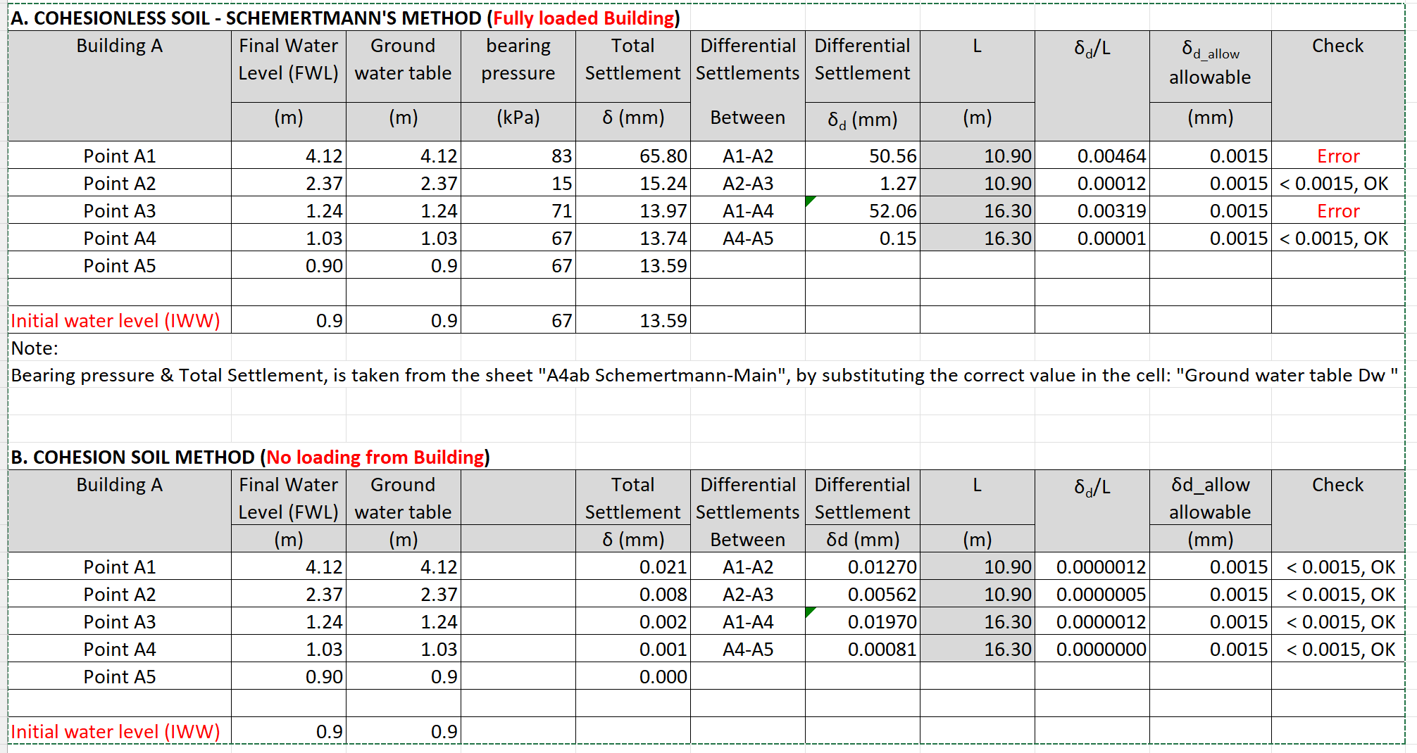

**Building C, Annex A5c (Excel sheet “A5c Build C-SettlementSum”)**

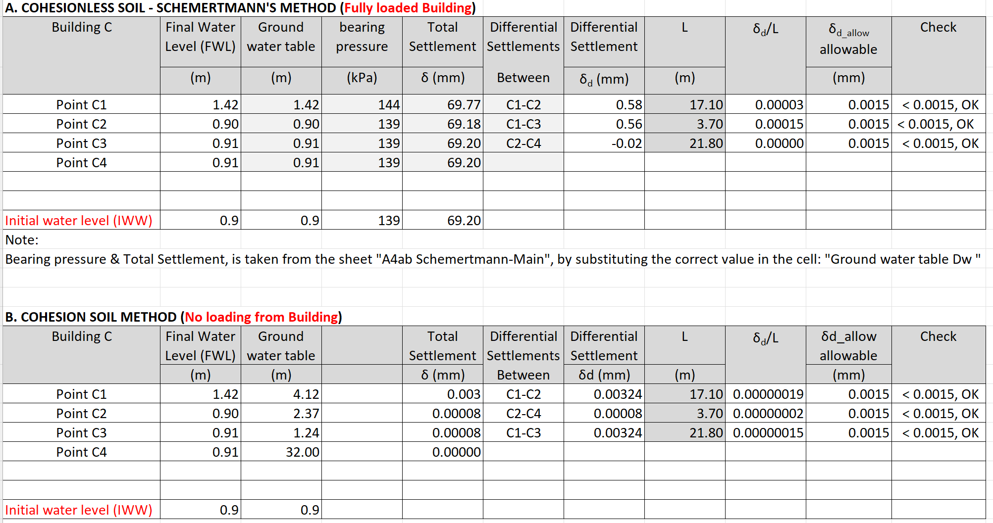

**Building B, Annex A6c (Excel sheet “A6c Build B-SettlementSum”)**

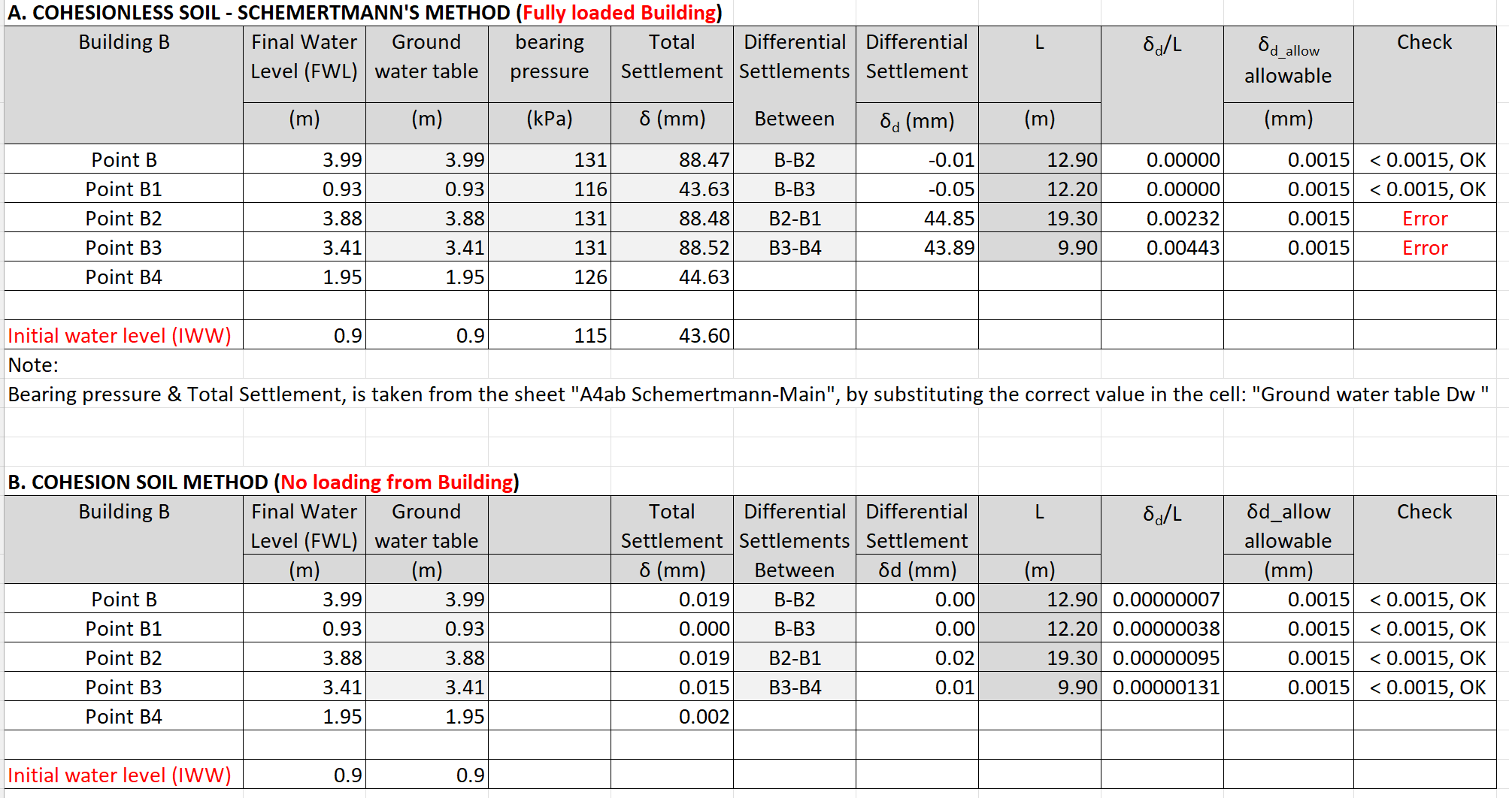

**Building D, Annex A7c (Excel sheet “A7c Build D-SettlementSum”)**

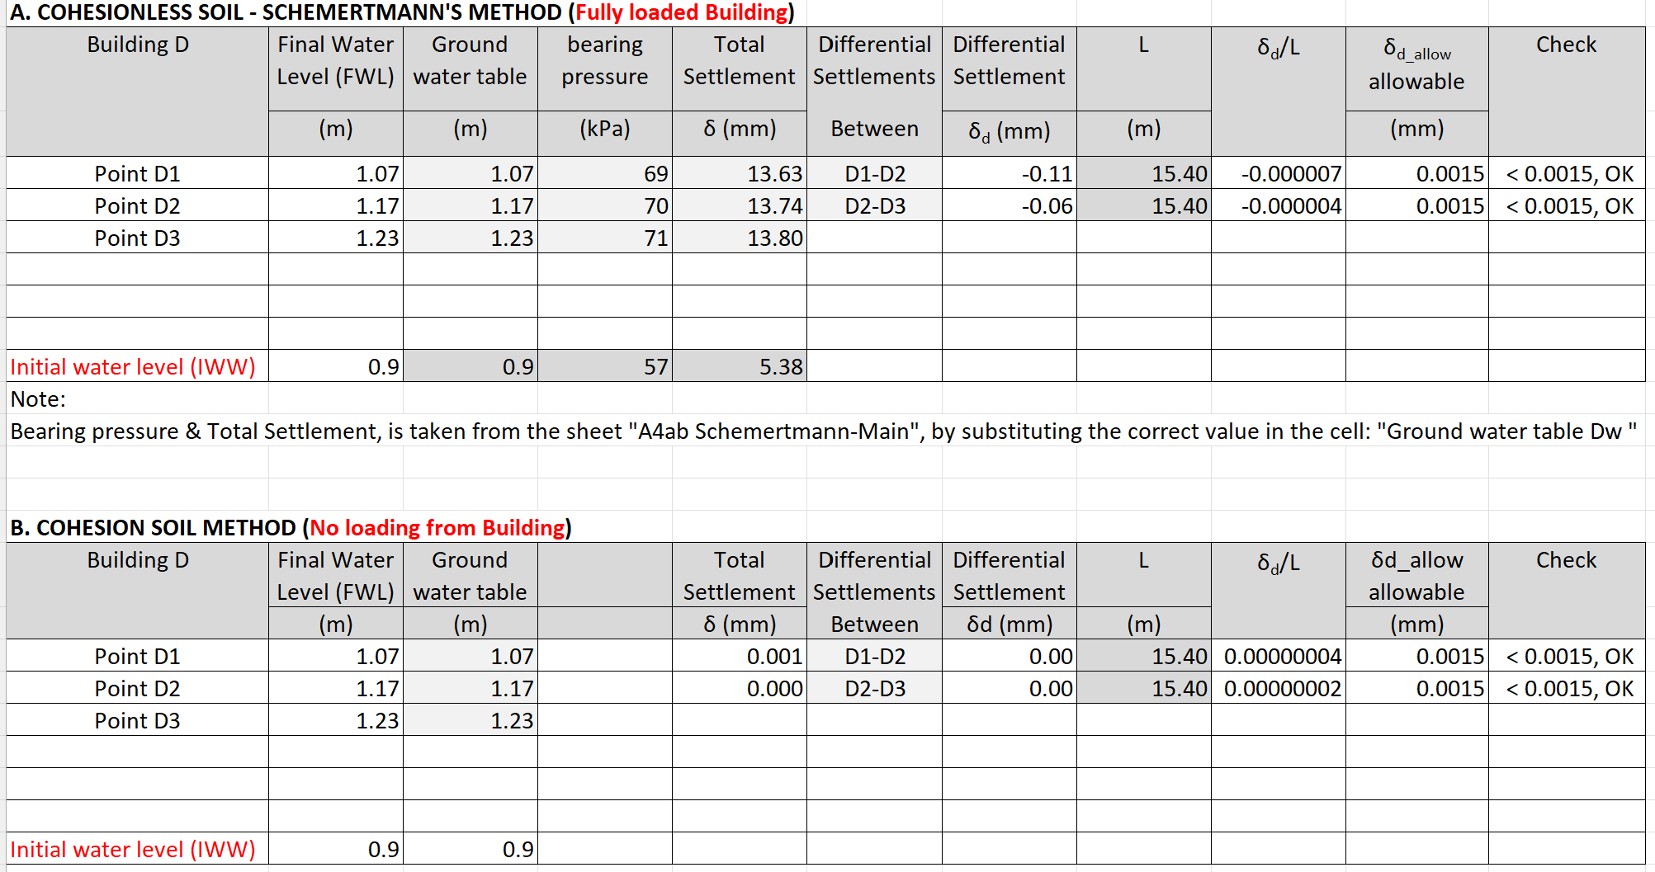

Point F - Analytical calculation (without loading from building):

* Point F (West), foundation level 2.5m, calculations as per the attached Annex A8b (Excel sheet “A8b\_SuperWells-F2.5m”): settlement 12 mm
* Point F (West), foundation level (-5.0m) calculations as per the attached Annex A8c (Excel sheet “A8c\_SuperWells-F5m”) : settlement 19 mm

#### Point A - Numerical calculation (additional surface loads):

* For Point F (West): the settlement at foundation level (-5.0m) is 49 mm
* For building B (South): the settlement at foundation level (-5.0m) is 66 mm.

### Problematic Differential Settlements at buildings Nodes

The allowable angular distortion, as per the Building Code (SBC-303), Table 5.2, is 0.0015

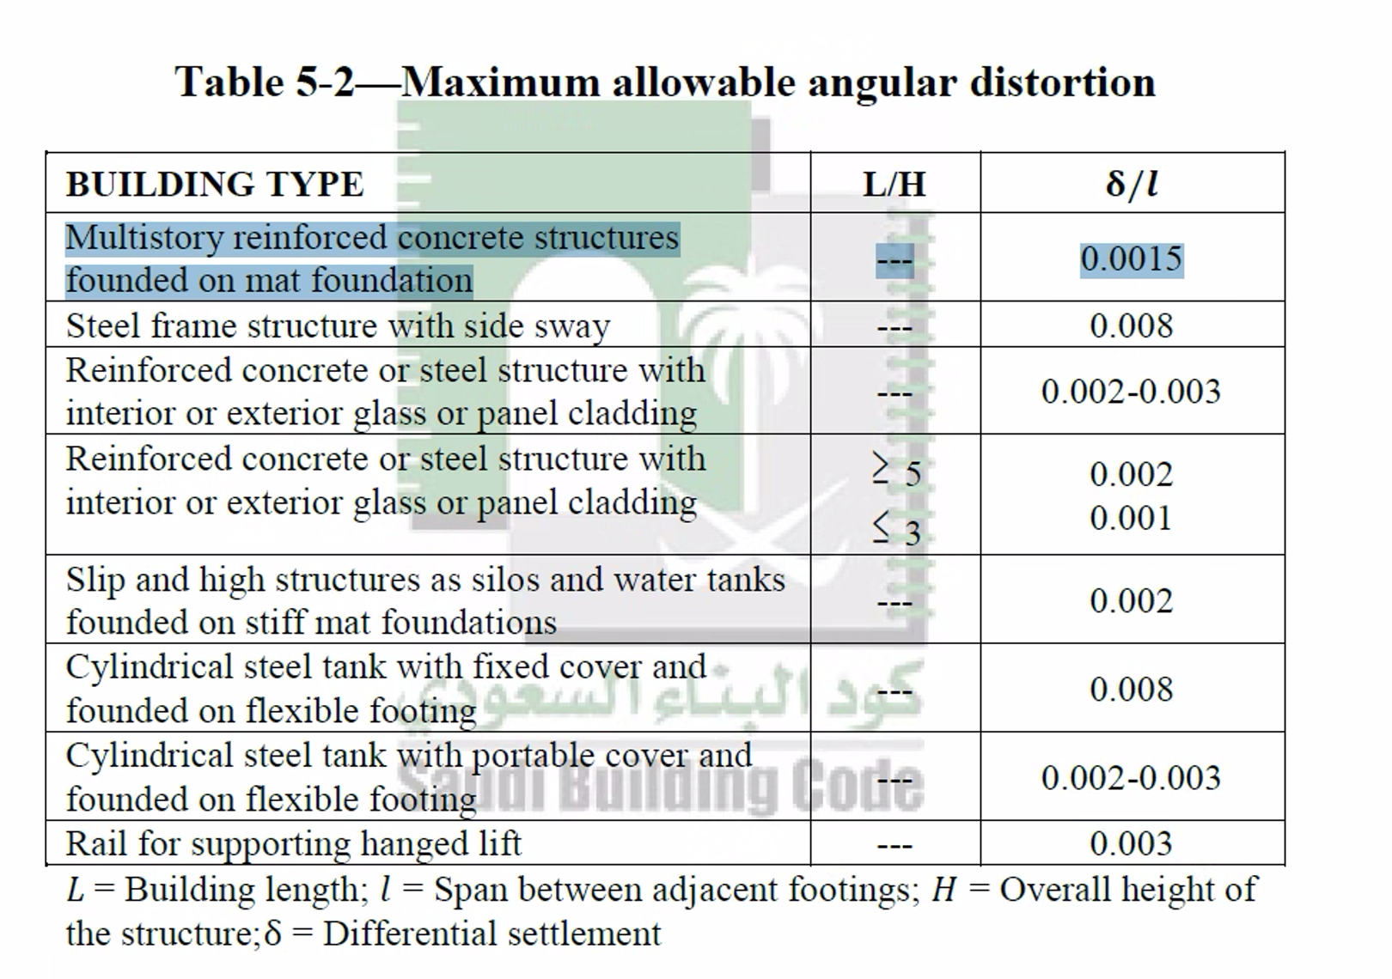

The following differential settlements at some front building points, exceed the allowable angular distortion of 0.0015

Building A: Α1-A2 and Α1-A4,

Building A: Β2-B1 and Β3-B4

These are worse case scenario settlements, based on cohesionless soil model, which is not totally true, since beneath the existing buildings, most probably will be layers of well graded engineering material.

Also, the settlements due to the loads from the buildings, have already been taken and soil consolidation has already been implemented.

Moreover, the distances between the points A1-A2 and B2-B1 that the angular distortion is calculated is 16.3 and 19.3m respectively, which is very large.

### Proposal for Improving Settlements

To reduce the effect on the neighboring buildings and specifically Building A and B, the pumping wells can be moved away from the corners A1, B2 and B3, as follows:

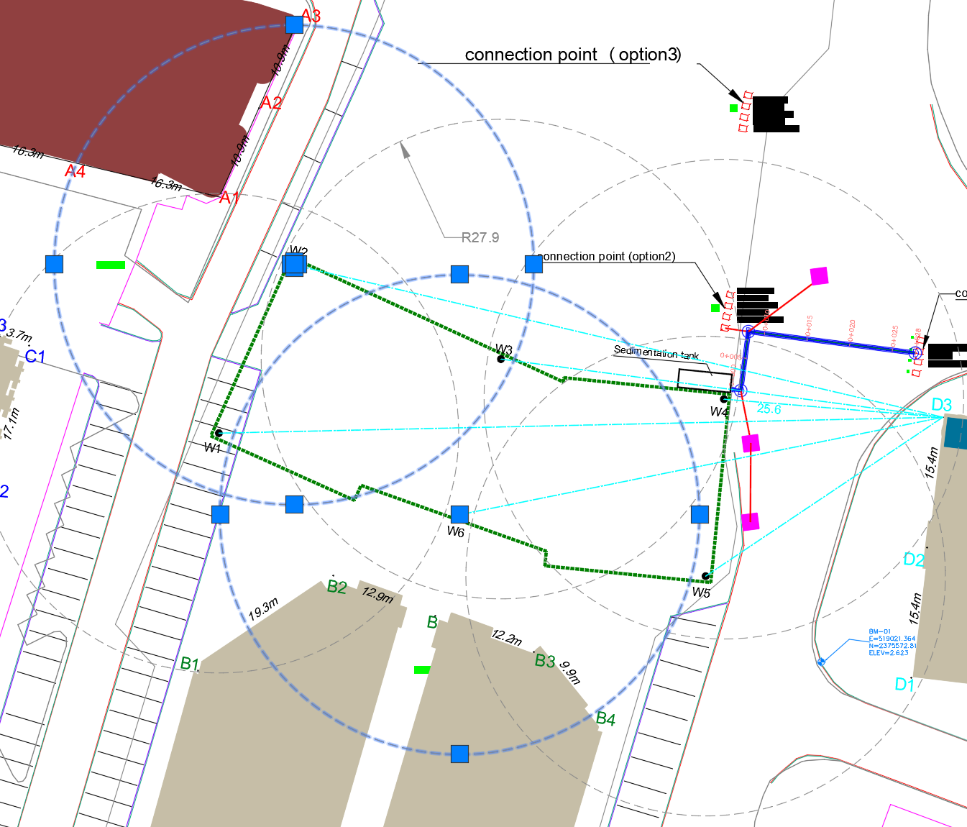

The new location, to avoid influence on the drawdown, is:

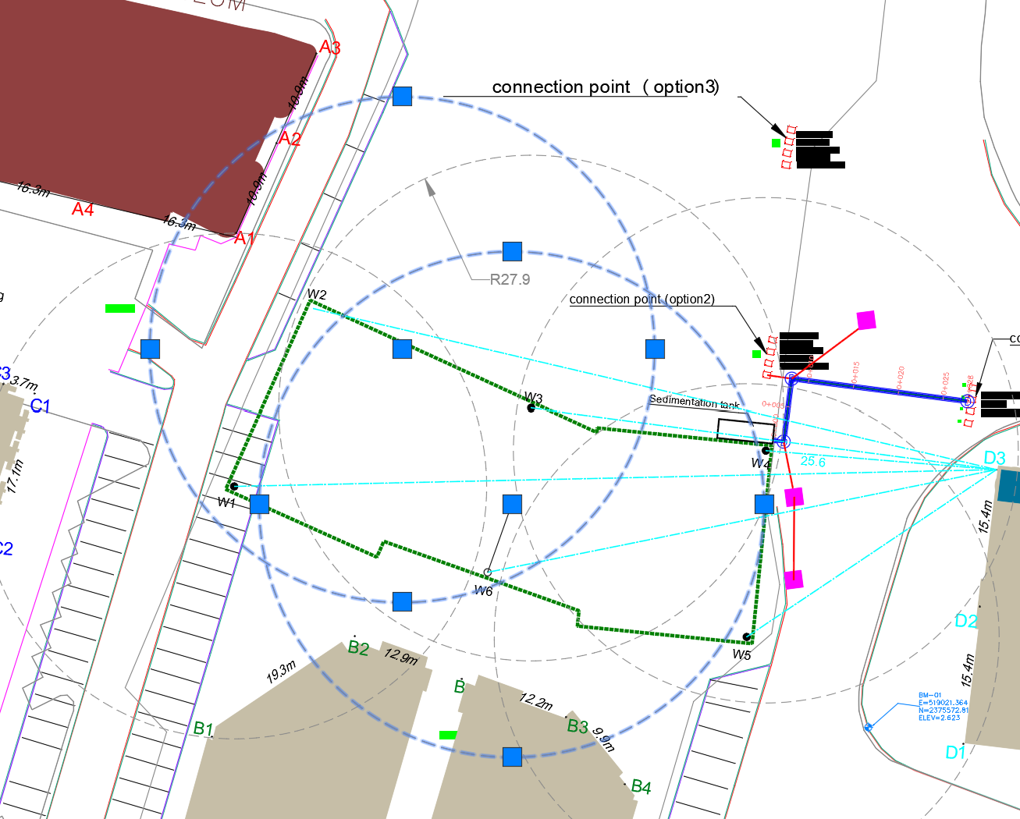

Also, to reduce the distances between the points as follows:

A1-A2 from 16.3m to 8m

B2-B1 from 19.3m to 8m

## Recommendation

The below are CONSULTANT’s recommendations and do not restrict the Client from designing and constructing the works in other acceptable engineering practices.

### Supporting system

As was explained above, there is no risk for damages to the heritage and neighboring buildings if the below recommendations will be followed, since:

* The numerical modeling analysis hgave settlements within acceptable limits.
* The excavation and foundation designer and specialized contractor have to design and construct the excavations supporting system, minimizing the deformations and settlements, keeping them within acceptable limits. The CONSULTANT is proposing the following methodology, on the condition that extensive design of the supporting system will be implemented by another designer and the specialized excavation and dewatering Contractor:
* To avoid risk to the adjacent heritage buildings, combination of Secant Piles wall (concrete piles diameter minimum 1.2m) with minimum double anchoring rows (at -1m and -3.5m depth) must be used, as indicated in the below sketch (do not take into account the indicated dimensions):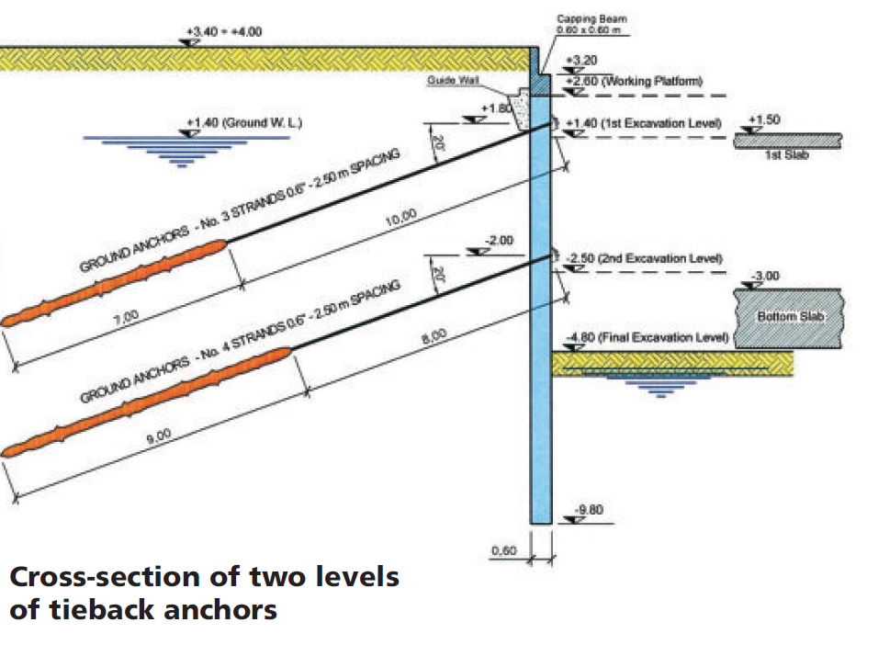
* Additional Supporting Struts or **Rakers** with kicker concrete boxes can be used at the boundaries of the excavated areas that are in close contact with existing buildings and near the pumping wells, as shown in the below photos:

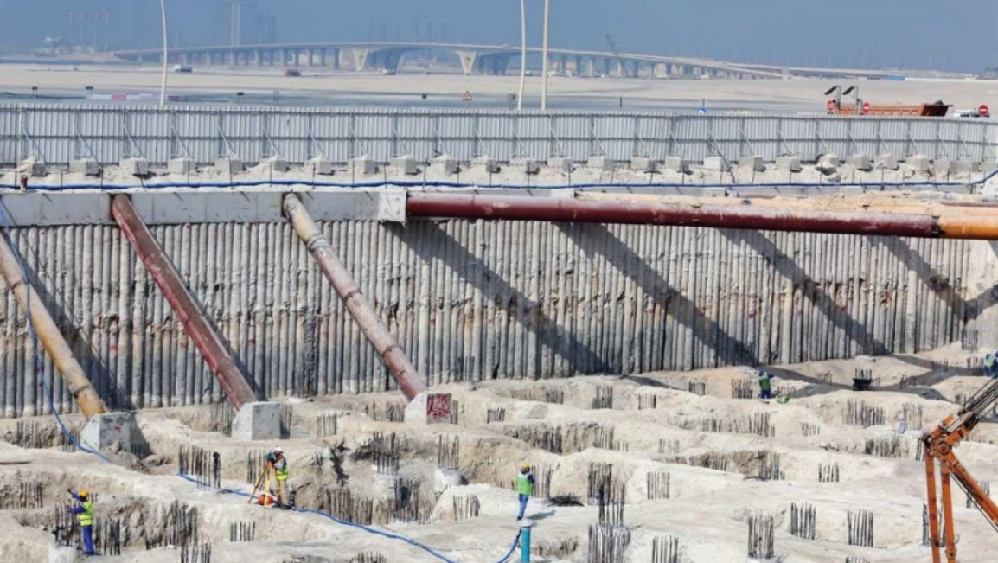

### Contractor’s precautious measures During Excavations

* Careful excavation and construction without disturbing the project area.
* The shoring secant piles should be casted in place to avoid vibrations.

# WORKS EXECUTION

## Execution steps

The dewatering works consist of three steps:

* The first step is divided into 2 activities running in parallel:
* Activity one is to complete the solid shoring around the site perimeter to block the horizontal flow of groundwater during dewatering operation.
* Activity two is to start installation of designed dewatering discharge line upon obtaining the permit from the supervision consultant.
* The second step is to install the **6** wells in their specified design locations, based on dewatering calculation as shown in the attached design, then monitor the water table inside the site to start the mass excavation work of the site.
* The third step is to construct filter drains at the final excavation level, connected to the **6** dewatering wells locations.

## Sequence of work

1- Proper shoring (as secant piles) around site perimeter to be completed.

2- In parallel, upon obtaining the permit, the registered in Amana subcontractor will apply for all necessary road and work permits and install the dewatering discharge line to be ready to discharge at the time of shoring completion.

3- The **6** wells locations to be marked on site and approved by all concerned parties.

4- Drilling and installation of the **6** dewatering wells.

Detail of dewatering well is shown in the attached drawings showing depth, filter material, solid and perforated parts of the riser pipes.

5- Installation of the piping around the excavation and the sedimentation tank

6- Installation of the discharge lines and connection the external storm network.

6- Running of dewatering system at the **6** locations and monitor the water table on site to progress with excavation work.

6- Continue pumping out water to the required contractual period to allow main contractor to construct the raft and basements works till reaching the desired level. The target water lowered level should be minimum 30cm under maximum excavation level.

## Control Panels

Control panels and generator will be installed for running the system, where each panel can operate several pumps. Entire system shall be monitored via an audio and visual alarm to provide warning and prevent any failure.

## Connection from pumps to discharge Lines

Upon installation of the discharge line, the riser pipes will be connected to the collection tank and all pumps are ready to operate pumping the groundwater into the collection (sedimentation) tank and from there to the discharged external lines. Plan showing exact location of sedimentation tanks and generators will be submitted from the specialized contractor to the management of the project for allocating suitable free location.

# COMMISSIONING

Once the system and installation completed and tested the dewatering system shall be started with the approval of all concerned parties and will be monitored by the Supervision Consultant during the dewatering period, reporting to Amana, as per the standard process.

# HEALTH AND SAFETY

The specialized contractor will ensure the application of Environmental, Health and safety standards applicable for the specific project

The Operational Risk Assessment report will be submitted from the specialized Contractor.

**References**

1. *A Practical Guide to Dewatering, 2nd Edition, Pat M. Cashman and Martin Preene*
2. *Construction dewatering and groundwater control, New Methods and Applications, J. PATRICK POWERS, P.E., ARTHUR B. CORWIN, et al*
3. *Deep excavation Theory and Practice Chang-Yu Ou 2006*
4. *Dewatering Guidelines for the City of Abu Dhabi PROJECT NO. 13-5015, Rev 1, 8/7/2014*
5. *Terzaghi et al. Soil Mechanics in Engineering practice*
6. *Bowles, J. E., Foundation Analysis and Design, The McGraw-Hill Companies, Inc., 5th Edition, para. 2-10.4,*
7. *NAFAC P-418*

# ANNEXES

|  |  |
| --- | --- |
| ANNEX [A1](file:///D:\SAK\Projects\Dewater\MultipleSites-BALAD\design\4-AlBunt\SAK\work\calcs\240313-AlBunt_calcs.xlsm#'A2 Meth1-BigWellEquival'!Print_Area) Pumps | Pump curves |
| ANNEX [A2](file:///D:\SAK\Projects\Dewater\MultipleSites-BALAD\design\4-AlBunt\SAK\work\calcs\240313-AlBunt_calcs.xlsm#'A2 Meth1-BigWellEquival'!Print_Area) Method1-Big Well Equivalent | Calculates the required pumping discharge quantity Q, to succeed the desirable water drawdown, modeling the excavation as one big well. The working pump capacity is taken from the sheet "A2 SuperWells-InsideProject" |
| ANNEX A3Superposition MethodWells-InsideProject | Calculates the water drawdown inside the project (3 points, one in the center and two at sides), based on wells superposition method. Also the working pump capacity is defined here, checking to succeed the required drawdown at all internal points |
| ANNEX [A4a](file:///D:\SAK\Projects\Dewater\MultipleSites-BALAD\design\4-AlBunt\SAK\work\calcs\240313-AlBunt_calcs.xlsm#'A4a SuperWells-A1,A2,A3,A4,A5'!Print_Area) Superposition MethodWells-A1,A2,A3,A4,A5Cohesion soil material | Calculates the water drawdown at the points A1, A2, A3, A4 and A5 of building A (foundation depth -2.50m), based on wells superposition method Also the settlements due to drawdown from the original level to the one after dewatering, based on cohesion soil formulas are calculated. Loads from the building are not considered, only the effect of change of the original and effective stresses and due to this the relevant settlements are taken into account. |
| ANNEX A4bBuilding ASchemertmann methodCohesionless soil material | Based on the previously found drawdowns, it calculates the bearing pressure and the settlements beneath a foundation of Building A (foundation depth -2.50m). The dimensions of the foundation and the total loading from the building is taken into account. The Schemertmann method concerning cohesionless soil is applied |
| ANNEX [A4c](file:///D:\SAK\Projects\Dewater\MultipleSites-BALAD\design\4-AlBunt\SAK\work\calcs\240313-AlBunt_calcs.xlsm#'A4c Build A-SettlementSum'!A1) Building ASchemertmann methodSummarizes Settlements | Summarizes the settlements and differential settlements of the two methodologies (cohesion and cohesionless) of Building A |
| ANNEX A5aSuperposition MethodWells- C1,C2,C3,C4,C5Cohesion soil material | Calculates the water drawdown at the points C1, C2, C3, C4 and C5 of building C (foundation depth -2.50m), based on wells superposition method . Also the settlements due to drawdown from the original level to the one after dewatering, based on cohesion soil formulas are calculated. Loads from the building are not considered, only the effect of change of the original and effective stresses and due to this the relevant settlements are taken into account. |
| ANNEX A5bBuilding CSchemertmann methodCohesionless soil material | Based on the previously found drawdowns, it calculates the bearing pressure and the settlements beneath a foundation of Building C (foundation depth -2.50m). The dimensions of the foundation and the total loading from the building is taken into account. The Schemertmann method concerning cohesionless soil is applied |
| ANNEX [A5c](file:///D:\SAK\Projects\Dewater\MultipleSites-BALAD\design\4-AlBunt\SAK\work\calcs\240313-AlBunt_calcs.xlsm#'A4c Build A-SettlementSum'!A1) Building CSchemertmann methodSummarizes Settlements | Summarizes the settlements and differential settlements of the two methodologies (cohesion and cohesionless) of Building C |
| ANNEX [A6a](file:///D:\SAK\Projects\Dewater\MultipleSites-BALAD\design\4-AlBunt\SAK\work\calcs\240313-AlBunt_calcs.xlsm#'A4c Build A-SettlementSum'!A1) Superposition MethodWells- B,B1,B2,B3,B4Cohesion soil material | Calculates the water drawdown at the points B1, B2, B3 and B4 of building B (foundation depth -2.50m), based on wells superposition method . Also the settlements due to drawdown from the original level to the one after dewatering, based on cohesion soil formulas are calculated. Loads from the building are not considered, only the effect of change of the original and effective stresses and due to this the relevant settlements are taken into account. |
| ANNEX A6bBuilding BSchemertmann methodCohesionless soil material | Based on the previously found drawdowns, it calculates the bearing pressure and the settlements beneath a foundation of Building B (foundation depth -2.50m). The dimensions of the foundation and the total loading from the building is taken into account. The Schemertmann method concerning cohesionless soil is applied |
| ANNEX [A6c](file:///D:\SAK\Projects\Dewater\MultipleSites-BALAD\design\4-AlBunt\SAK\work\calcs\240313-AlBunt_calcs.xlsm#'A4c Build A-SettlementSum'!A1) Building BSchemertmann methodSummarizes Settlements | Summarizes the settlements and differential settlements of the two methodologies (cohesion and cohesionless) of Building B |
| ANNEX [7a](file:///D:\SAK\Projects\Dewater\MultipleSites-BALAD\design\4-AlBunt\SAK\work\calcs\240313-AlBunt_calcs.xlsm#'A4c Build A-SettlementSum'!A1) Superposition MethodWells- D1,D2,D3Cohesion soil material | Calculates the water drawdown at the points D1, D2 and D3 of building D (foundation depth -2.50m), based on wells superposition method . Also the settlements due to drawdown from the original level to the one after dewatering, based on cohesion soil formulas are calculated. Loads from the building are not considered, only the effect of change of the original and effective stresses and due to this the relevant settlements are taken into account. |
| ANNEX A7bBuilding DSchemertmann methodCohesionless soil material | Based on the previously found drawdowns, it calculates the bearing pressure and the settlements beneath a foundation D (foundation deth -2.50m). The dimensions of the foundation and the total loading from the building is taken into account. The Schemertmann method concerning cohesionless soil is applied |
| [A7c Build D-SettlementSum](file:///D:\SAK\Projects\Dewater\MultipleSites-BALAD\design\4-AlBunt\SAK\work\calcs\240313-AlBunt_calcs.xlsm#'A7c Build D-SettlementSum'!A1)ANNEX [A7c](file:///D:\SAK\Projects\Dewater\MultipleSites-BALAD\design\4-AlBunt\SAK\work\calcs\240313-AlBunt_calcs.xlsm#'A4c Build A-SettlementSum'!A1) Building DSchemertmann methodSummarizes Settlements | Summarizes the settlements and differential settlements of the two methodologies (cohesion and cohesionless) of Building D |
| [A8 Loads of Neighbor Buildings](file:///D:\SAK\Projects\Dewater\MultipleSites-BALAD\design\4-AlBunt\SAK\work\calcs\240313-AlBunt_calcs.xlsm#'A8 LoadsNeighborBuildings'!A1) | Estimates the loads of the neighboring buildings on their foundation, together with their dimensions |
| ANNEX [8a](file:///D:\SAK\Projects\Dewater\MultipleSites-BALAD\design\4-AlBunt\SAK\work\calcs\240313-AlBunt_calcs.xlsm#'A4c Build A-SettlementSum'!A1) Superposition MethodPoint BCohesion soil material | Calculates the water drawdown at the point B of building B (foundation deth -5.0m), based on wells superposition method . Also the settlements due to drawdown from the original level to the one after dewatering, based on cohesion soil formulas are calculated. Loads from the building are not considered, only the effect of change of the original and effective stresses and due to this the relevant settlements are taken into account. |
| ANNEX [8b](file:///D:\SAK\Projects\Dewater\MultipleSites-BALAD\design\4-AlBunt\SAK\work\calcs\240313-AlBunt_calcs.xlsm#'A4c Build A-SettlementSum'!A1) Superposition MethodPoint FCohesion soil materialFoundation depth 2.50m | Calculates the water drawdown at the point F (foundation depth -2.5m), based on wells superposition method . Also the settlements due to drawdown from the original level to the one after dewatering, based on cohesion soil formulas are calculated. Loads from the building are not considered, only the effect of change of the original and effective stresses and due to this the relevant settlements are taken into account. |
| [A8c\_SuperWells-F5m](file:///D:\SAK\Projects\Dewater\MultipleSites-BALAD\design\4-AlBunt\SAK\work\calcs\240313-AlBunt_calcs.xlsm#'A8c_SuperWells-F5m'!A1)ANNEX [8c](file:///D:\SAK\Projects\Dewater\MultipleSites-BALAD\design\4-AlBunt\SAK\work\calcs\240313-AlBunt_calcs.xlsm#'A4c Build A-SettlementSum'!A1) Superposition MethodPoint FCohesion soil materialFoundation depth 5.00m | Calculates the water drawdown at the point F (foundation depth -5.0m), based on wells superposition method . Also the settlements due to drawdown from the original level to the one after dewatering, based on cohesion soil formulas are calculated. Loads from the building are not considered, only the effect of change of the original and effective stresses and due to this the relevant settlements are taken into account. |
| -ANNEX [A9](file:///D:\SAK\Projects\Dewater\MultipleSites-BALAD\design\4-AlBunt\SAK\work\calcs\240313-AlBunt_calcs.xlsm#'A9 DewaterLinesSizing'!A1) Dewater Lines Sizing | Calculates the pipeline diameters from the pumps to the sedimentation tank and from the project to the external storm line connection |
| ANNEX [A10](file:///D:\SAK\Projects\Dewater\MultipleSites-BALAD\design\4-AlBunt\SAK\work\calcs\240313-AlBunt_calcs.xlsm#'A10 FilterPack'!A1) FilterPack calculations | Calculates the required Filter pack in each pump well |
| ANNEX [A11](file:///D:\SAK\Projects\Dewater\MultipleSites-BALAD\design\4-AlBunt\SAK\work\calcs\240313-AlBunt_calcs.xlsm#'A11 WellScreen'!A1) WellScreen calculations | Calculates the required Well screen in each pump well |
| [ANNEX A12](file:///D:\SAK\Projects\Dewater\MultipleSites-BALAD\design\4-AlBunt\SAK\work\calcs\240313-AlBunt_calcs.xlsm#'A12 Permeability'!A1) Permeability index | Presents the permeability indexes as per the Geotechnical reports and selects one |
| [ANNEX A13](file:///D:\SAK\Projects\Dewater\MultipleSites-BALAD\design\4-AlBunt\SAK\work\calcs\240313-AlBunt_calcs.xlsm#'A12 Permeability'!A1) PLAXIS NUMERICAL ANAL |  |

ANNEX 1

PUMPS

Note: The proposed model is indicative, any other acceptable from authorities pump with similar characteristics, can be used

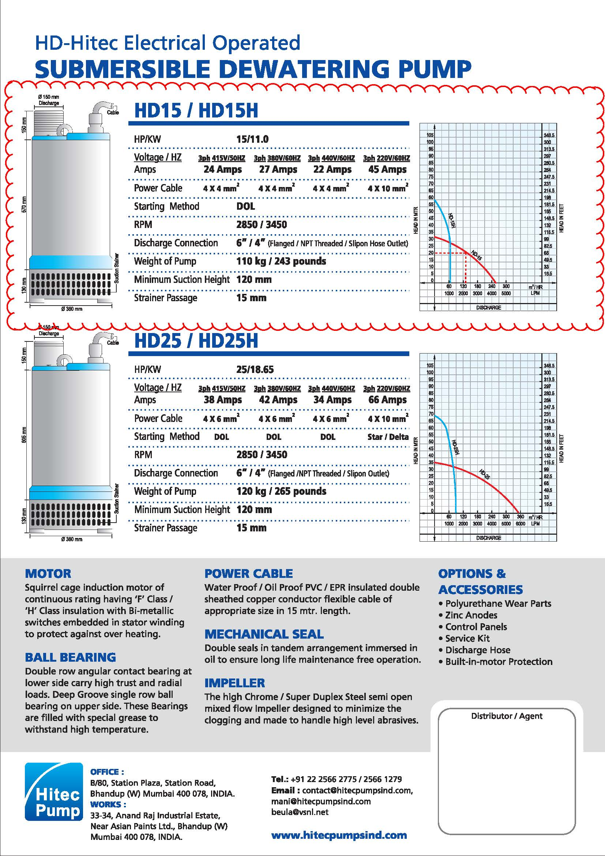

ANNEX 13

PLAXIS NUMERICAL ANALYSIS

(Displacement calculations)